|  |  |  |  |  |
| --- | --- | --- | --- | --- |
|  |  | | |  |
| **Huawei eSight for SCCM Plug-in**  **V1.3.5** | | |
| **User Guide** | | |
| **Issue** | **01** | |
| **Date** | **2020-05-06** | |
|  | | | | |
|  | HUAWEI TECHNOLOGIES CO., LTD. | |  |  |

|  |
| --- |
| **Copyright © Huawei Technologies Co., Ltd. 2020. All rights reserved.**  No part of this document may be reproduced or transmitted in any form or by any means without prior written consent of Huawei Technologies Co., Ltd.  **Trademarks and Permissions**  and other Huawei trademarks are trademarks of Huawei Technologies Co., Ltd.  All other trademarks and trade names mentioned in this document are the property of their respective holders.  **Notice**  The purchased products, services and features are stipulated by the contract made between Huawei and the customer. All or part of the products, services and features described in this document may not be within the purchase scope or the usage scope. Unless otherwise specified in the contract, all statements, information, and recommendations in this document are provided "AS IS" without warranties, guarantees or representations of any kind, either express or implied.  The information in this document is subject to change without notice. Every effort has been made in the preparation of this document to ensure accuracy of the contents, but all statements, information, and recommendations in this document do not constitute a warranty of any kind, express or implied. |

|  |  |
| --- | --- |
| Huawei Technologies Co., Ltd. | |
| Address: | Huawei Industrial Base  Bantian, Longgang  Shenzhen 518129  People's Republic of China |
| Website: | <https://e.huawei.com> |
|  |  |

Preface

Purpose

This document describes how to install and uninstall the Huawei SCCM plug-in, add eSight, and use the Huawei SCCM plug-in to manage Huawei servers.

Intended Audience

This document is intended for:

* Installation and commissioning engineers
* Technical support engineers

Symbol Conventions

The symbols that may be found in this document are defined as follows.

|  |  |
| --- | --- |
|  | Indicates an imminently hazardous situation which, if not avoided, will result in death or serious injury. |
|  | Indicates a potentially hazardous situation which, if not avoided, could result in death or serious injury. |
|  | Indicates a potentially hazardous situation which, if not avoided, may result in minor or moderate injury. |
|  | Indicates a potentially hazardous situation which, if not avoided, could result in equipment damage, data loss, performance deterioration, or unanticipated results.  NOTICE is used to address practices not related to personal injury. |
|  | Calls attention to important information, best practices and tips.  NOTE is used to address information not related to personal injury, equipment damage, and environment deterioration. |

Change History

Changes between document issues are cumulative. The latest document issue contains all the changes made in earlier issues.

| Issue | Release Date | Description |
| --- | --- | --- |
| 01 | 2020-05-06 | This issue is the first official release. |

Contents

Preface ii

1 Overview 1

2 Installing and Uninstalling the Huawei SCCM Plug-in 3

2.1 Installing the Huawei SCCM Plug-in 3

2.2 Uninstalling the Huawei SCCM Plug-in 6

3 Operation and Maintenance 12

3.1 Configuring eSight 12

3.1.1 Adding eSight 12

3.1.2 Editing eSight 16

3.1.3 Deleting eSight 19

3.2 Managing Servers 21

3.2.1 Viewing the Server List 21

3.2.2 Deploying an OS 23

3.2.2.1 Adding a Software Source 23

3.2.2.2 Adding an OS Template 29

3.2.2.3 Adding a Template Task 36

3.2.3 Configuring a Server 40

3.2.3.1 Configuring Power Control 40

3.2.3.2 Configuring the BIOS 45

3.2.3.3 Configuring an HBA 60

3.2.3.4 Configuring RAID 67

3.2.3.5 Configuring a CNA 74

3.2.3.6 Configuring the iBMC 85

3.2.4 Upgrading the Firmware and Driver 92

3.2.4.1 Uploading an Upgrade Package 92

3.2.4.2 Upgrading the Firmware and Driver 97

3.3 Viewing the Huawei SCCM Plug-in Version 102

4 FAQs 104

4.1 Connection Test Failed When Adding an eSight 104

4.2 Failed to Deploy an OS 106

4.3 Failed to Upload an Upgrade Package 110

A Obtaining Help 111

A.1 Preparing to Contact Huawei Technical Support 111

A.2 Obtaining Help from Huawei Support Website 111

# Overview

Function Description

The Huawei SCCM plug-in is a plug-in integrated in the System Center Configuration Manager (SCCM for short) software and used for Huawei server management. By adding eSight, it can implement the OS deployment, server configuration, and upgrade functions on Huawei servers.

You can implement the following functions by using the Huawei SCCM plug-in:

* Deploy OSs on servers in batches. Table 3-3 lists the OSs that can be deployed.
* Configure CNAs, HBAs, BMCs, BIOSs, and RAIDs of servers.
* Upgrade server firmware and drivers.



The actual functions depend on the functions provided by eSight.

Supported Servers

| Type | Server Model |
| --- | --- |
| Rack server | RH2288H V2 |
| RH1288 V3 |
| RH2288 V3 |
| RH2288H V3 |
| RH5885 V3 |
| RH8100 V3 |
| 1288H V5 |
| 2288H V5 |
| 2488 V5 |
| Blade server | E9000 |
| High-density server | XH321 V3 |
| XH620 V3 |
| XH622 V3 |
| XH628 V3 |

# Installing and Uninstalling the Huawei SCCM Plug-in

2.1 Installing the Huawei SCCM Plug-in

2.2 Uninstalling the Huawei SCCM Plug-in

## Installing the Huawei SCCM Plug-in

Log in to [GitHub](https://github.com/Huawei/Server_Management_Plugin_SCCM/tree/master/releases), and obtain the plug-in installation package.

Upload the Huawei SCCM plug-in installation package to the SCCM server OS.

Log in to the SCCM server as an administrator.

Decompress the Huawei SCCM plug-in installation package on the SCCM server.

The Huawei SCCM plug-in installation program (such as **Huawei_SCCM_Plugin_*x.x.x*.exe**) is obtained.

Double-click the Huawei SCCM plug-in installation program.

The language selection window is displayed, as shown in Figure 2-1.

Selecting a language

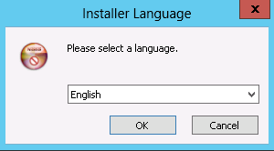

Select an installation language, and click **OK**.

The installation wizard is displayed, as shown in Figure 2-2.

Installation wizard

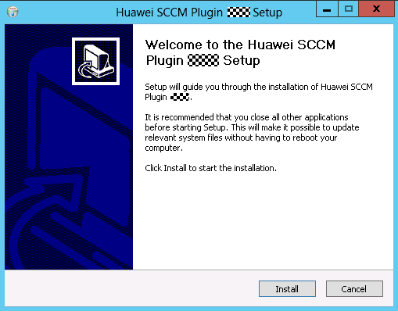

Click **Install**.

The Huawei SCCM plug-in installation starts, as shown in Figure 2-3.

Installation progress

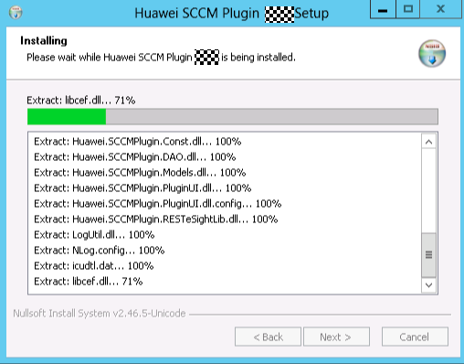

When the installation is complete, the window shown in Figure 2-4 is displayed.

Installation completed

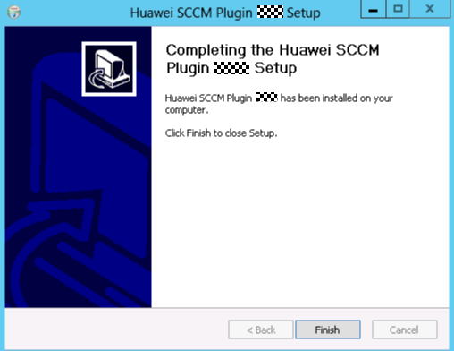

Click **Finish**.

The installation is complete.

----End

## Uninstalling the Huawei SCCM Plug-in

Log in to the SCCM server as an administrator.

Uninstall the Huawei SCCM plug-in.

* Uninstall the Huawei SCCM plug-in from the Control Panel.
  1. Choose **Start** > **Control Panel** > **Programs** > **Uninstall a program**.

The **Programs and Features** window is displayed, as shown in Figure 2-5.

Programs and Features

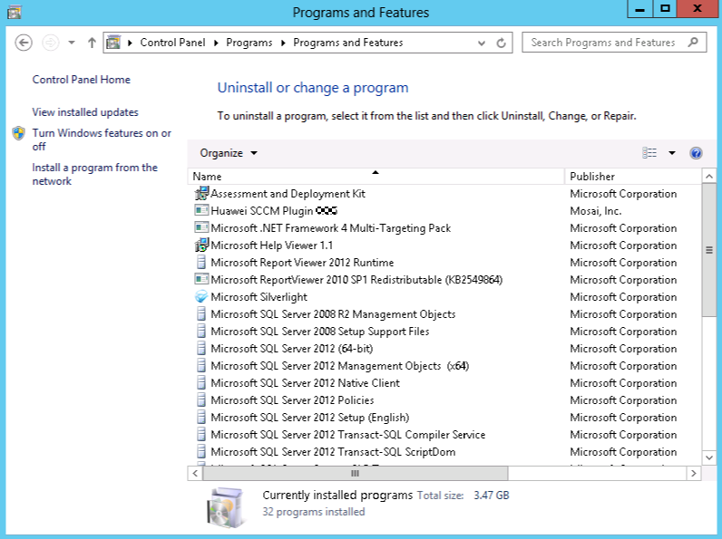

* 1. Find the Huawei SCCM plug-in (such as **Huawei_SCCM_Plugin_*x.x.x***) and double-click it.

The language selection window is displayed, as shown in Figure 2-6.

Selecting a language



* 1. Select an uninstallation language, and click **OK**.

The confirmation dialog box is displayed, as shown in Figure 2-7.

Dialog box

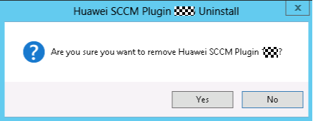

* 1. Confirm the uninstallation, and click **Yes**.

The Huawei SCCM plug-in uninstallation starts, and a dialog box prompting you to confirm data deletion is displayed, as shown in Figure 2-8.

Dialog box

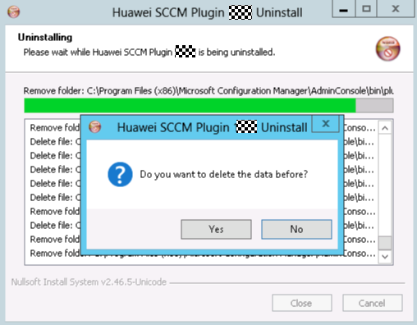

* 1. Confirm the data deletion, and click **Yes**.

A dialog box indicating successful uninstallation is displayed, as shown in Figure 2-9.

Dialog box

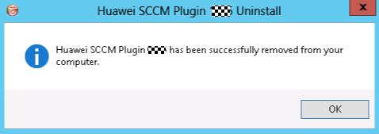

* 1. Click **OK**.

The plug-in is uninstalled successfully.

* Uninstall the Huawei SCCM plug-in from the Huawei SCCM plug-in installation directory.
  1. Go to the Huawei SCCM plug-in installation directory, as shown in Figure 2-10.

Going to the Huawei SCCM plug-in installation directory



* 1. Find the Huawei SCCM plug-in uninstallation program **Huawei SCCM Plugin Uninst.exe** and double-click it.

The language selection window is displayed, as shown in Figure 2-11.

Selecting a language



* 1. Select an uninstallation language, and click **OK**.

The confirmation dialog box is displayed, as shown in Figure 2-12.

Dialog box

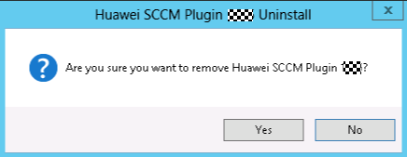

* 1. Confirm the uninstallation, and click **Yes**.

The Huawei SCCM plug-in uninstallation starts, and a dialog box prompting you to confirm data deletion is displayed, as shown in Figure 2-13.

Dialog box

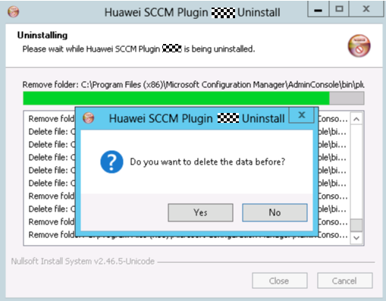

* 1. Confirm the data deletion, and click **Yes**.

A dialog box indicating successful uninstallation is displayed, as shown in Figure 2-14.

Dialog box

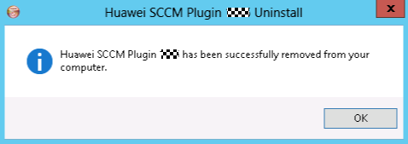

* 1. Click **OK**.

The plug-in is uninstalled successfully.

----End

# Operation and Maintenance

3.1 Configuring eSight

3.2 Managing Servers

3.3 Viewing the Huawei SCCM Plug-in Version

## Configuring eSight

### Adding eSight



Information of an eSight system added by the current login user cannot be viewed by a user who does not add the eSight system.

Set a whitelist.

By default, a whitelist of eSight northbound ports is configured. To add an eSight system properly, you must add the IP address of the server where SCCM is located to the whitelist of eSight northbound ports.

1. Log in to the eSight WebUI.
2. Choose **System** > **Northbound Integration** > **Third-party System** > **Create**.

The **Third-party System** page is displayed, as shown in Figure 3-1.

Third-party System

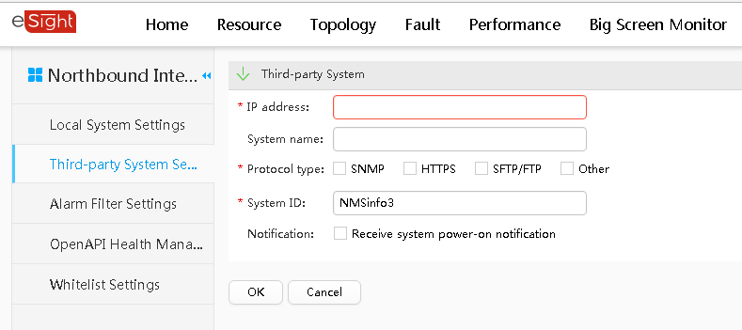

1. Set the following parameters:

* **IP address**: Set this parameter to the IP address of the SCCM server.
* **Protocol type**: Select **HTTPS**.
* **System ID**: Retain the default value or enter a new value. The value can be an IP address or a string of 1 to 64 characters, including digits (0-9), lowercase letters (a-z), uppercase letters (A-Z), and special characters @_- (), .^$~`!.

1. Click **OK**.

The IP address of the SCCM server is set as a whitelist, as shown in Figure 3-2.

Set successfully

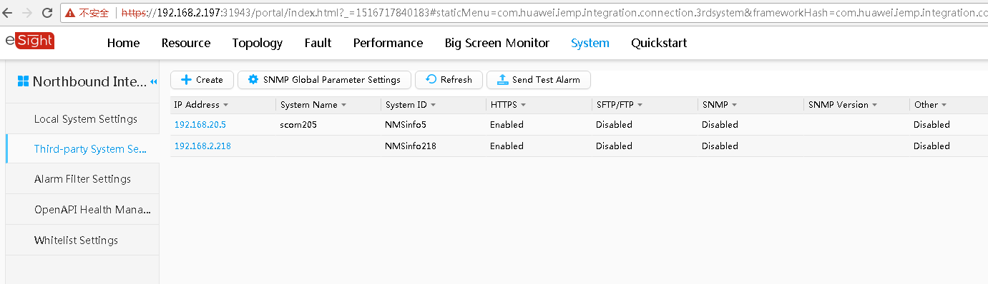

Log in to the SCCM server.

Choose **Start** > **Configuration Manager Console** to log in to the SCCM.



If **Configuration Manager Console** cannot be found on the **Start** panel, return to the desktop, right-click **Start**, choose **Search** from the shortcut menu, and enter **Configuration Manager Console** in the search box to find **Configuration Manager Console**.

The SCCM main window is displayed, as shown in Figure 3-3.

SCCM main window

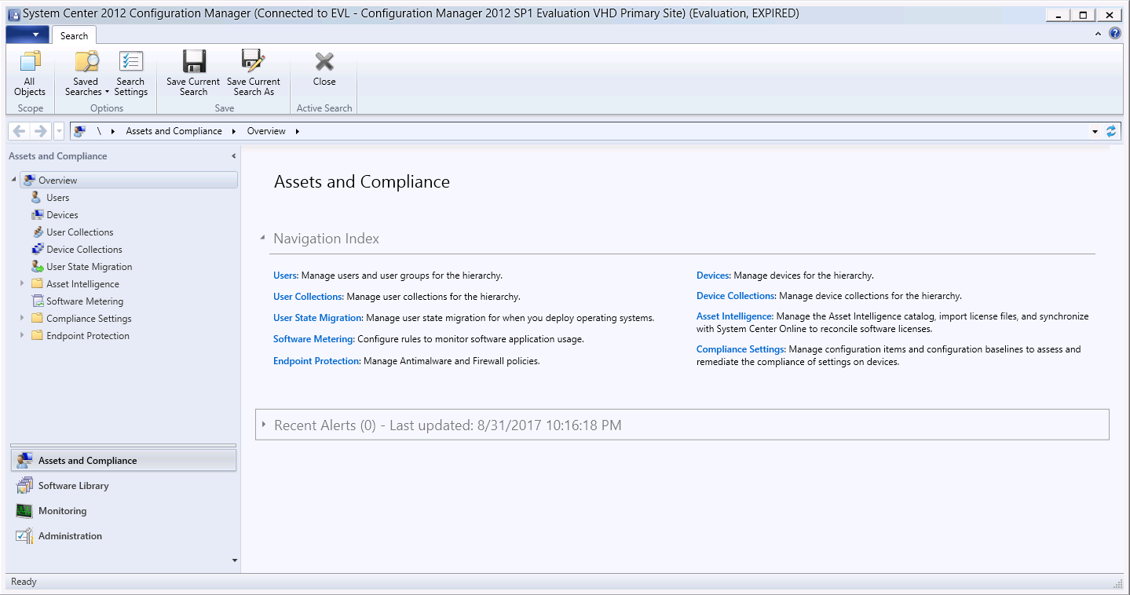

Click **Software Library**.

The **Software Library** window is displayed, as shown in Figure 3-4.

Software Library

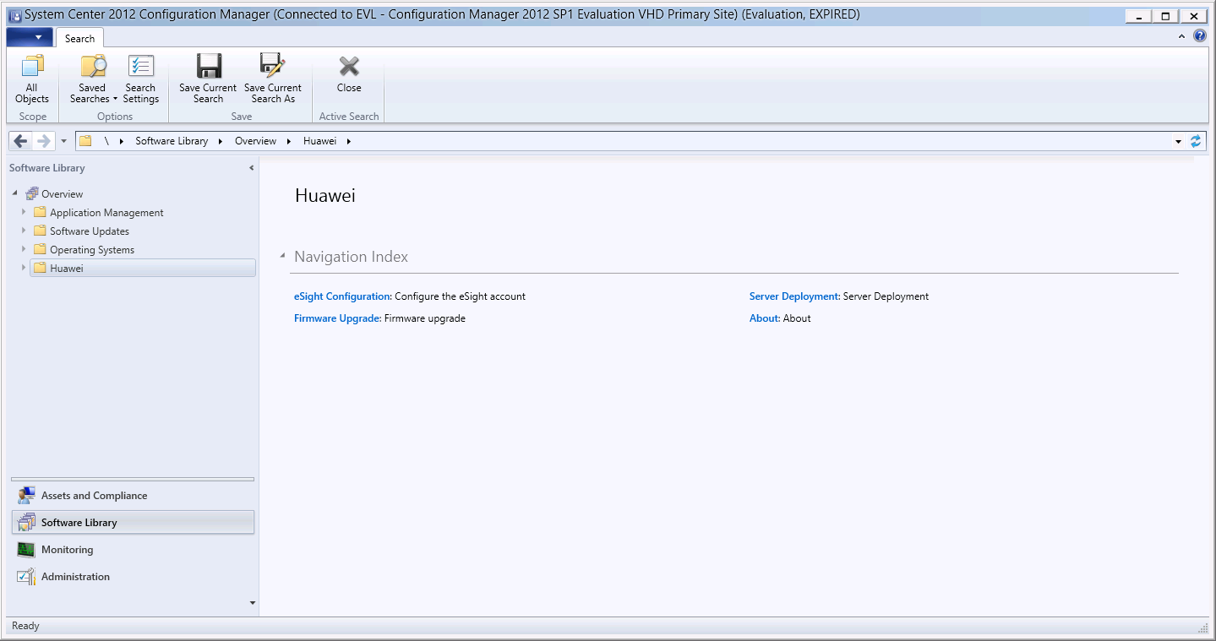

Choose **Huawei** > **eSight Configuration**.

The **eSight Configuration** window is displayed, as shown in Figure 3-5.

eSight Configuration

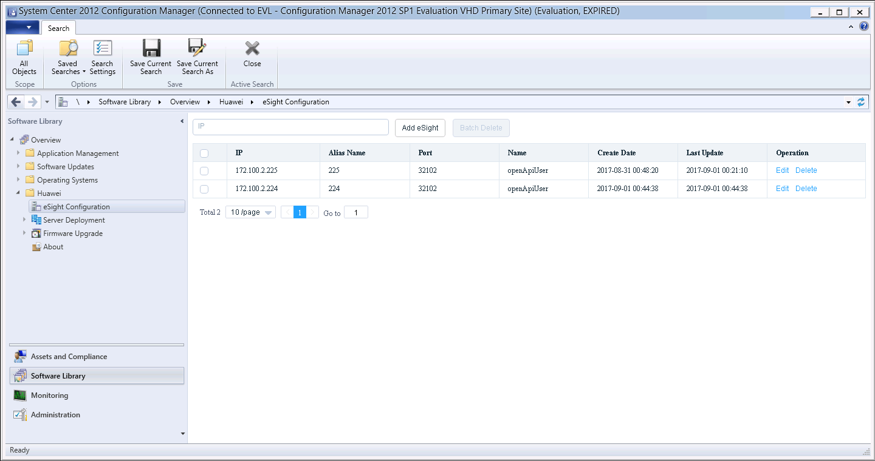

Click **Add eSight**.

The **Add eSight** window is displayed, as shown in Figure 3-6.

Add eSight

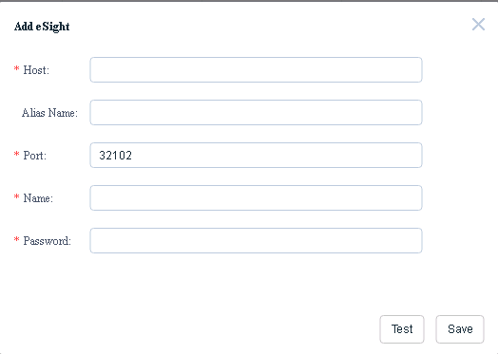

Table 3-1 describes the parameters.

Parameter description

| Parameter | Description | Mandatory |
| --- | --- | --- |
| Host | eSight IP address. | Yes |
| Alias Name | Customized eSight name. The value contains 1 to 100 characters and supports letters, digits, underscores, em dashes (**—**), and dots (**.**). | No |
| Port | eSight northbound port number. The default value is **32102**. | Yes |
| Name | eSight northbound port user name. The default value is **openApiUser**. | Yes |
| Password | eSight northbound port password. The default value is **Huawei12#$**. To change the password, follow the instructions in 4.1 Connection Test Failed When Adding an eSight. | Yes |

Enter eSight information according to Table 3-1, and click **Test** to check whether the configuration information is correct.

If **Link test success** is displayed in the window, the entered eSight information is correct. If any error occurs, enter eSight information again.

Click **Save**.

A dialog box indicating successful adding is displayed, as shown in Figure 3-7.

Dialog box

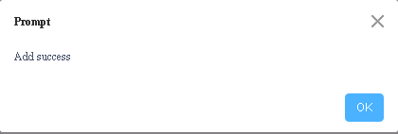

Click **OK**.

The eSight is added successfully.

----End

### Editing eSight

Log in to the SCCM server.

Choose **Start** > **Configuration Manager Console** to log in to the SCCM.



If **Configuration Manager Console** cannot be found on the **Start** panel, return to the desktop, right-click **Start**, choose **Search** from the shortcut menu, and enter **Configuration Manager Console** in the search box to find **Configuration Manager Console**.

The SCCM main window is displayed, as shown in Figure 3-8.

SCCM main window



Click **Software Library**.

The **Software Library** window is displayed, as shown in Figure 3-9.

Software Library



Choose **Huawei** > **eSight Configuration**.

The **eSight Configuration** window is displayed, as shown in Figure 3-10.

eSight Configuration



Click **Edit** in the row where the eSight to be edited is located.

The **Edit eSight** window is displayed, as shown in Figure 3-11.

Edit eSight

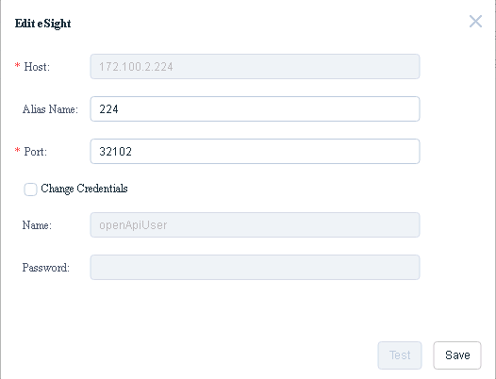

Edit eSight information according to Table 3-1, and click **Save**.



* The eSight IP address cannot be modified.
* **Change Credentials** must be selected if the eSight user name and password are to be changed.

A dialog box indicating successful editing is displayed, as shown in Figure 3-12.

Dialog box

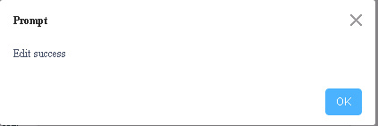

Click **OK**.

The eSight is edited successfully.

----End

### Deleting eSight

Log in to the SCCM server.

Choose **Start** > **Configuration Manager Console** to log in to the SCCM.



If **Configuration Manager Console** cannot be found on the **Start** panel, return to the desktop, right-click **Start**, choose **Search** from the shortcut menu, and enter **Configuration Manager Console** in the search box to find **Configuration Manager Console**.

The SCCM main window is displayed, as shown in Figure 3-13.

SCCM main window



Click **Software Library**.

The **Software Library** window is displayed, as shown in Figure 3-14.

Software Library



Choose **Huawei** > **eSight Configuration**.

The **eSight Configuration** window is displayed, as shown in Figure 3-15.

eSight Configuration



Click **Delete** in the row where the eSight is located.

The confirmation dialog box is displayed, as shown in Figure 3-16.

Dialog box

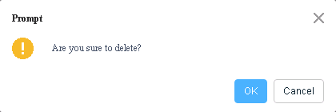

You can select multiple eSight systems and click **Batch Delete** to delete them in batches.

Click **OK**.

The eSight is deleted successfully.

----End

## Managing Servers

### Viewing the Server List

Log in to the SCCM server.

Choose **Start** > **Configuration Manager Console** to log in to the SCCM.



If **Configuration Manager Console** cannot be found on the **Start** panel, return to the desktop, right-click **Start**, choose **Search** from the shortcut menu, and enter **Configuration Manager Console** in the search box to find **Configuration Manager Console**.

The SCCM main window is displayed, as shown in Figure 3-17.

SCCM main window



Click **Software Library**.

The **Software Library** window is displayed, as shown in Figure 3-18.

Software Library



Choose **Huawei** > **Server Deployment** > **Server List**.

The **Server List** window is displayed, as shown in Figure 3-19.

Server List

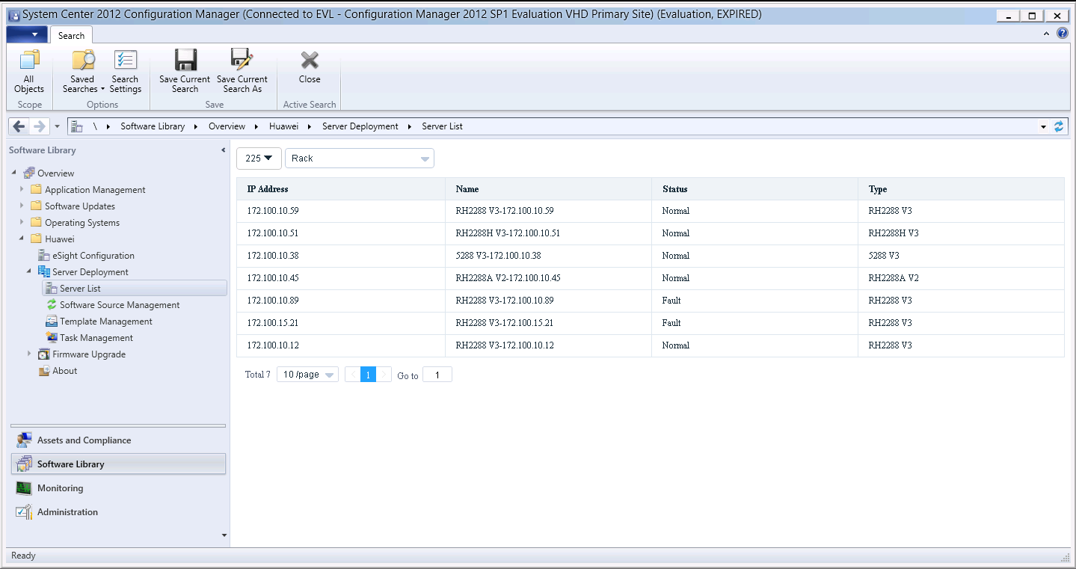

You can view the servers managed by each eSight system in this window.



* **225** in Figure 3-19 indicates the eSight alias. You can select another eSight system from the drop-down list box.
* **Rack** in Figure 3-19 indicates the rack server. You can select **Blade** (blade server) or **Highdensity** (high-density server) from the drop-down list box.

----End

### Deploying an OS

#### Adding a Software Source

Scenario

Adding a software source indicates adding an OS image file. To deploy an OS on a server, you need to add an OS image file, add an OS template, and add an OS deployment task.

Prerequisites

* The SFTP server for uploading the software source has been set up.
* The OS compatibility of the server has been confirmed using the [Huawei Server Compatibility Checker](http://support.huawei.com/onlinetoolsweb/ftca/indexEn?serise=2), and Note1 is present in the **Notes** column. For details, see 4.2 Failed to Deploy an OS.

Procedure

Upload the OS image file to be added to the default directory on the SFTP server.



* The size of the OS image file must not exceed 5 GB.
* The capacity of the eSight installation disk must be greater than 40 GB.

Log in to the SCCM server.

Choose **Start** > **Configuration Manager Console** to log in to the SCCM.



If **Configuration Manager Console** cannot be found on the **Start** panel, return to the desktop, right-click **Start**, choose **Search** from the shortcut menu, and enter **Configuration Manager Console** in the search box to find **Configuration Manager Console**.

The SCCM main window is displayed, as shown in Figure 3-20.

SCCM main window



Click **Software Library**.

The **Software Library** window is displayed, as shown in Figure 3-21.

Software Library



Choose **Huawei** > **Server Deployment** > **Software Source Management**.

The **Software Source Management** window is displayed, as shown in Figure 3-22.

Software Source Management

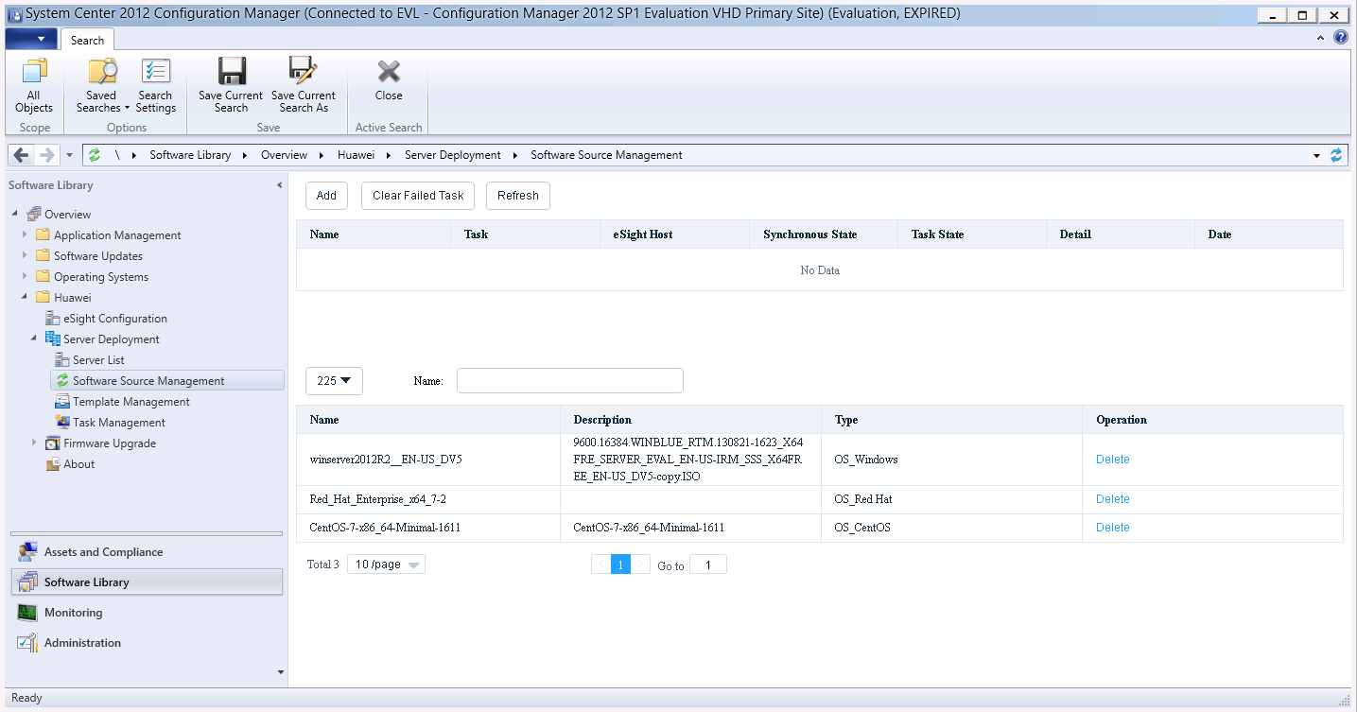

Click **Add**.

The **Add Software Source** window is displayed, as shown in Figure 3-23.

Add Software Source

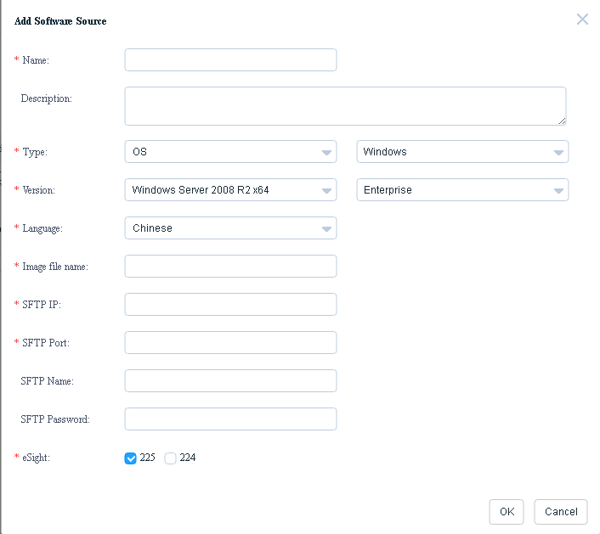

Table 3-2 describes the parameters.

Parameter description

| Parameter | Description | Value | Mandatory |
| --- | --- | --- | --- |
| Name | Software source name. | The value contains only letters, digits, underscores, and hyphens (**-**). The length ranges from 6 to 32 characters. | Yes |
| Description | Software source description. | The value contains 0 to 128 characters. | No |
| Type | Software source type. | The types include Windows, SUSE, Red Hat, CentOS, Ubuntu, and VMWare ESXi. | Yes |
| Version | Software source version. | A software source type includes one or multiple versions. For details, see Table 3-3. | Yes |
| Language | Software source language. | You can set this parameter to **Chinese** or **English**. | This parameter is mandatory if the software source type is set to **Windows**. You do not need to set this parameter if the software source type is set to another value. |
| Image file name | Software source name.  NOTE  The OS image file to be added must be placed in the default path on the SFTP server in advance. | The full name of the OS image file must contain **.iso**. | Yes |
| SFTP IP | SFTP server IP address. | - | Yes |
| SFTP Port | SFTP server port number. | The value ranges from 0 to 65535. | Yes |
| SFTP Name | SFTP server user name. | - | Yes |
| SFTP Password | SFTP server password. | The password contains 0 to 64 characters. | Yes |
| eSight | eSight to which the software source is to be added. You can select one or multiple eSight systems. | - | Yes |

Supported software source versions

| Software Source Type | Version |
| --- | --- |
| Windows | Windows Server 2008 R2 x64 |
| Windows Server 2008 R2 SP1 x64 |
| Windows Server 2012 x64 |
| Windows Server 2012 R2 x64 |
| Windows Server 2016 x64 |
| SUSE | SUSE Linux Enterprise 11 SP1 x64 |
| SUSE Linux Enterprise 11 SP2 x64 |
| SUSE Linux Enterprise 11 SP3 x64 |
| SUSE Linux Enterprise 11 SP4 x64 |
| SUSE Linux Enterprise 12 SP1 x64 |
| SUSE Linux Enterprise 12 x64 |
| Red Hat | Red Hat Linux Enterprise 6.1 x64 |
| Red Hat Linux Enterprise 6.2 x64 |
| Red Hat Linux Enterprise 6.3 x64 |
| Red Hat Linux Enterprise 6.4 x64 |
| Red Hat Linux Enterprise 6.5 x64 |
| Red Hat Linux Enterprise 6.6 x64 |
| Red Hat Linux Enterprise 6.7 x64 |
| Red Hat Linux Enterprise 6.8 x64 |
| Red Hat Linux Enterprise 7.0 x64 |
| Red Hat Linux Enterprise 7.1 x64 |
| Red Hat Linux Enterprise 7.2 x64 |
| CentOS | CentOS Linux Enterprise 6.2 x64 |
| CentOS Linux Enterprise 6.3 x64 |
| CentOS Linux Enterprise 6.4 x64 |
| CentOS Linux Enterprise 6.5 x64 |
| CentOS Linux Enterprise 6.6 x64 |
| CentOS Linux Enterprise 6.7 x64 |
| CentOS Linux Enterprise 7.0 x64 |
| CentOS Linux Enterprise 7.1 x64 |
| CentOS Linux Enterprise 7.2 x64 |
| Ubuntu | Ubuntu Linux Enterprise 14.04 x64 |
| VMWare ESXi | VMWare ESXi 5.0 x64 |
| VMWare ESXi 5.1 x64 |
| VMWare ESXi 5.5 x64 |
| VMWare ESXi 6.0 x64 |

Enter software source information according to Table 3-2, as shown in Figure 3-24.

Entering software source information

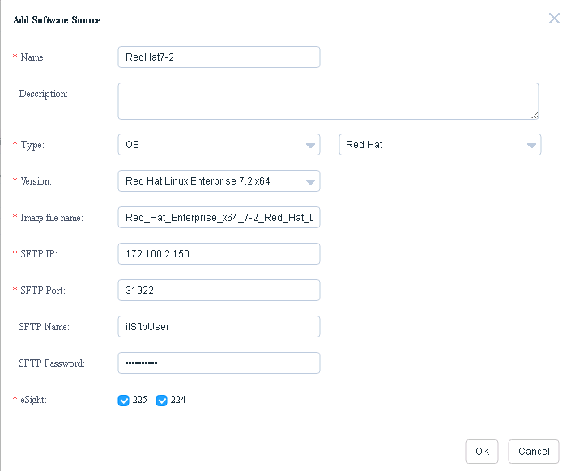

Click **OK**.

A dialog box indicating successful adding is displayed, as shown in Figure 3-25.

Dialog box

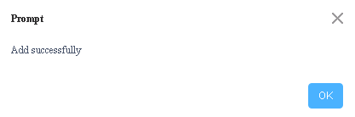

Click **OK**.

The software source is added successfully. You can click **Refresh** to refresh the window. Then you can view the added software source in the software source list, as shown in Figure 3-26.

Software source list

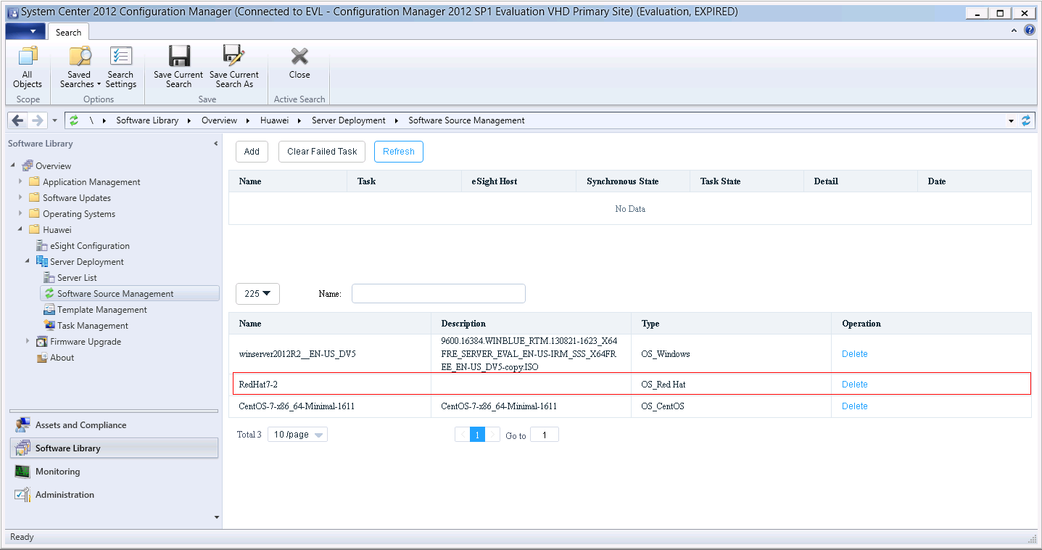

* If a software source fails to be uploaded, detailed information about the task will be displayed in the table above the software source list and the value of **Task State** will change to **Failed**. You can click **Clear Failed Task** to delete all failed tasks.
* You can click **Delete** in the row where a software source is located to delete the software source.

----End

#### Adding an OS Template

Log in to the SCCM server.

Choose **Start** > **Configuration Manager Console** to log in to the SCCM.



If **Configuration Manager Console** cannot be found on the **Start** panel, return to the desktop, right-click **Start**, choose **Search** from the shortcut menu, and enter **Configuration Manager Console** in the search box to find **Configuration Manager Console**.

The SCCM main window is displayed, as shown in Figure 3-27.

SCCM main window



Click **Software Library**.

The **Software Library** window is displayed, as shown in Figure 3-28.

Software Library



Choose **Huawei** > **Server Deployment** > **Template Management**.

The **Template Management** window is displayed, as shown in Figure 3-29.

Template Management

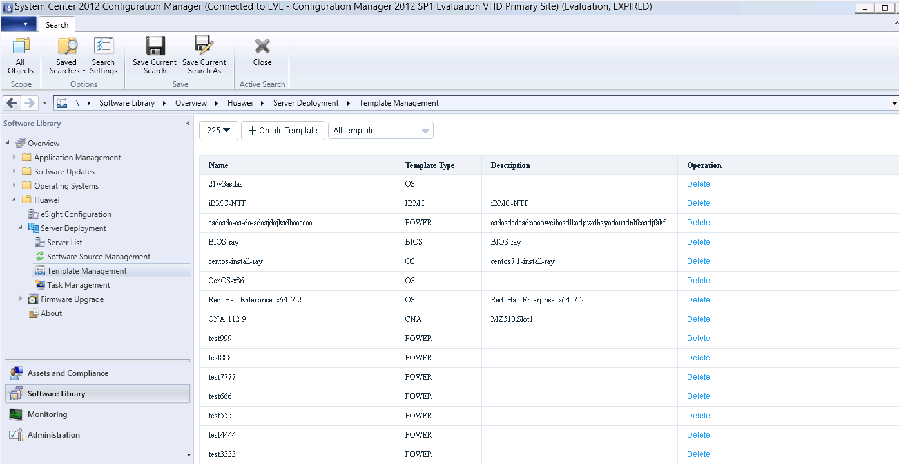

* **225** indicates the customized eSight name. You can select another eSight system from the drop-down list box.
* **All template** indicates that all templates are to be viewed. You can select another option from the drop-down list box to view specified templates. For example, you can select **OS template** to view OS templates.

Click **Create Template**.

The window for creating a template is displayed, as shown in Figure 3-30.

Creating a template

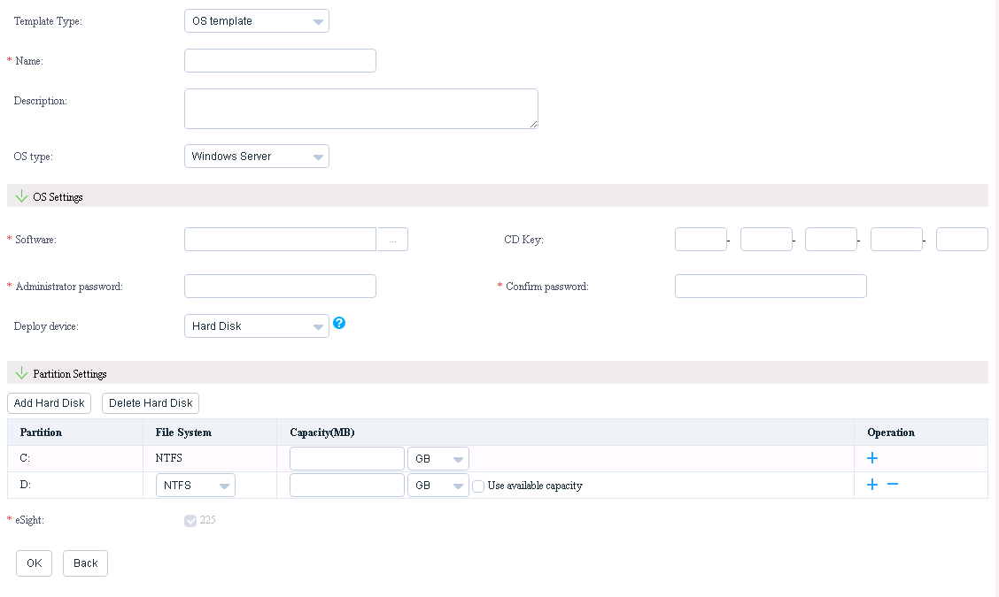

Enter OS template information according to Table 3-4, as shown in Figure 3-31.

Entering OS template information

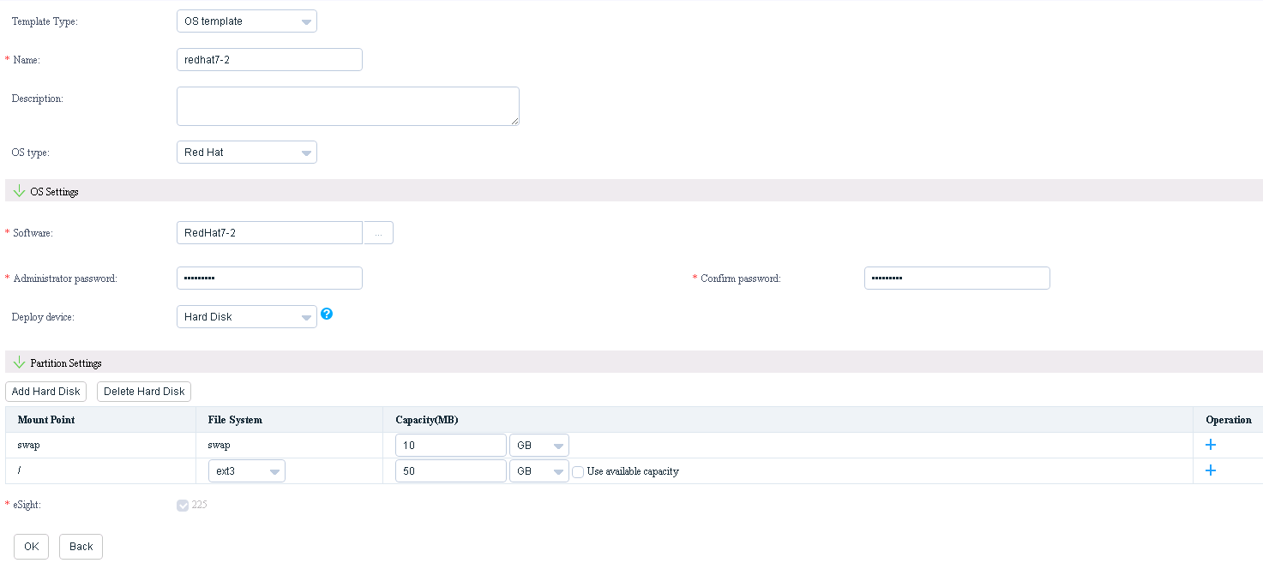

Parameter description

| Parameter | Description | Value | Mandatory |
| --- | --- | --- | --- |
| Template Type | Template type. | Select **OS template**. | Yes |
| Name | Template name. | The value contains letters, digits, underscores, and hyphens (**-**). The length ranges from 6 to 32 characters. | Yes |
| Description | Template description. | The value contains 0 to 128 characters. | No |
| OS type | OS type. | The options include **Windows Server**, **SUSE Linux**, **Red Hat**, **CentOS**, **VMware ESXi 5.0**, **VMware ESXi 5.1/5.5/6.0**, and **Ubuntu**. | Yes |
| Software | Software source name. | The value must be the same as the name of the uploaded software source. You can also directly select the uploaded software source. | Yes |
| CD Key | Key. | The value includes five groups of data. Each group of data contains five characters, including digits and letters. | This parameter needs to be set only when **OS type** is set to **Windows Server**. |
| Administrator password | OS administrator password. | The value contains 8 to 32 characters and must consist of at least two types of the following characters: uppercase letters, lowercase letters, digits, and special characters (`~!@$%......&*()-_=+|[{}];:' ",<.>/? #). | Yes |
| Confirm password | Password for confirmation. | The value needs to be the same as the configured OS administrator password. | Yes |
| Deploy device | OS deployment device. | The options include **USB device**, **Hard Disk**, and **San Boot**.  NOTE  For VMware ESXi 5.0, only **Hard Disk** is available. For VMware ESXi 5.1/5.5/6.0, only **USB device** and **Hard Disk** are available. | Yes |
| Partition Settings | Partition settings. | For details, see Table 3-5 and Table 3-6. | This parameter needs to be set when **OS type** is set to **Windows Server**, **SUSE Linux**, **Red Hat**, or **CentOS**. |
| eSight | eSight. | The current eSight is selected by default and cannot be changed. | Yes |

Partition setting description (**OS type** is set to **Windows Server**)

| Parameter | Description | Value | Mandatory |
| --- | --- | --- | --- |
| Partition | Partition name. | Value range: C to V.  NOTE  The first hard disk has at least one partition of which the name is **C**. If other partitions are added, the names are from **D** to **V**. The names of partitions on other hard disks are from **D** to **V** and cannot be the same as the names that have been used on the first hard disk. | Yes |
| File System | File system. | The options include **NTFS** and **FAT32**.  NOTE  The value of **File System** of partition C must be **NTFS**. This parameter can be set to **NTFS** or **FAT32** for other partitions. | Yes |
| Capacity(MB) | Capacity. | The unit can be **GB** or **MB**. The capacity of partition C ranges from 32 GB to 2000 GB or from 32000 MB to 2000000 MB. For other partitions, the capacity ranges from 1 GB to 32 GB or from 1000 MB to 32000 MB if **File System** is set to **FAT32** and ranges from 1 GB to 1000 GB or from 1000 MB to 999999 MB if **File System** is set to **NTFS**. | Yes |
| Operation | Partition adding or reduction. | - | No |
| Use available capacity | Use of the remaining capacity. | If **Use available capacity** is selected, the partition will use the remaining capacity. | The parameter needs to be set for the last partition. |

Partition setting description (**OS type** is set to **SUSE Linux**, **Red Hat**, or **CentOS**)

| Parameter | Description | Value (OS type Is Set to SUSE Linux) | Value (OS type Is Set to Red Hat or CentOS) | Mandatory |
| --- | --- | --- | --- | --- |
| Mount Point | Mount point name. | The options are as follows:   * swap * / * /home * /user * /opt * /boot * /media * /tmp * /var * /root * /usr * /sys * /srv   NOTE  The first hard disk has at least two mount points, and the mount points are named **swap** and **\**. Other mount points can be named the rest of the preceding values or be named by the user. The mount point names cannot be duplicated. The names of mount points on other hard disks must be different from the mount point names that have been used on the first hard disk. The names of mount points on other hard disks can also be customized. A customized name must start with **/** and consist of digits, letters, and underscores, and the length cannot exceed 255 characters. | | Yes |
| File System | File system. | The options are as follows:   * swap * reiser * ext2 * ext3 * ext4   NOTE  If the mount point is **swap**, **File System** must be set to **swap**. For other mount points, this parameter can be set to **reiser**, **ext2**, **ext3**, or **ext4**. | The options are as follows:   * swap * ext2 * ext3 * ext4   NOTE  If the mount point is **swap**, **File System** must be set to **swap**. For other mount points, this parameter can be set to **ext2**, **ext3**, or **ext4**. | Yes |
| Capacity(MB) | Capacity. | The unit can be **GB** or **MB**. If the mount point is **/**, the capacity ranges from 10000 MB to 999999 MB or from 10 GB to 1000 GB. For other mount points, the capacity ranges from 1000 MB to 999999 MB or from 1 GB to 1000 GB. | | Yes |
| Operation | Mount point adding or reduction. | - | | No |
| Use available capacity | Use of the remaining capacity. | If **Use available capacity** is selected, the mount point will use the remaining capacity. This parameter is available for mount point **/** and the last mount point of each hard disk. This parameter is unavailable for mount point **swap** and in other scenarios. | | No |

Click **OK**.

A dialog box indicating successful adding is displayed, as shown in Figure 3-32.

Dialog box



Click **OK**.

The OS template is added successfully, and you can view the added OS template in the template list, as shown in Figure 3-33.

Template list



To delete a template, click **Delete** in the row where the template is located.

----End

#### Adding a Template Task

Prerequisites

You have obtained the ServiceCD from the **Software Download** tab on the [**FusionServer Tools**](https://support.huawei.com/enterprise/en/servers/fusionserver-tools-pid-21015513/software) page at [Huawei Enterprise](http://support.huawei.com/enterprise/en/index.html) support website, uploaded the decompressed package to **eSight installation directory\AppBase\var\iemp\data\ftp**, and changed the name of the ServiceCD file to **FusionServer Tools-ServiceCD2.0-V110.iso**.



The ServiceCD version is V137.

Procedure

Log in to the SCCM server.

Choose **Start** > **Configuration Manager Console** to log in to the SCCM.



If **Configuration Manager Console** cannot be found on the **Start** panel, return to the desktop, right-click **Start**, choose **Search** from the shortcut menu, and enter **Configuration Manager Console** in the search box to find **Configuration Manager Console**.

The SCCM main window is displayed, as shown in Figure 3-34.

SCCM main window



Click **Software Library**.

The **Software Library** window is displayed, as shown in Figure 3-35.

Software Library



Choose **Huawei** > **Server Deployment** > **Task Management**.

The **Task Management** window is displayed, as shown in Figure 3-36.

Task Management

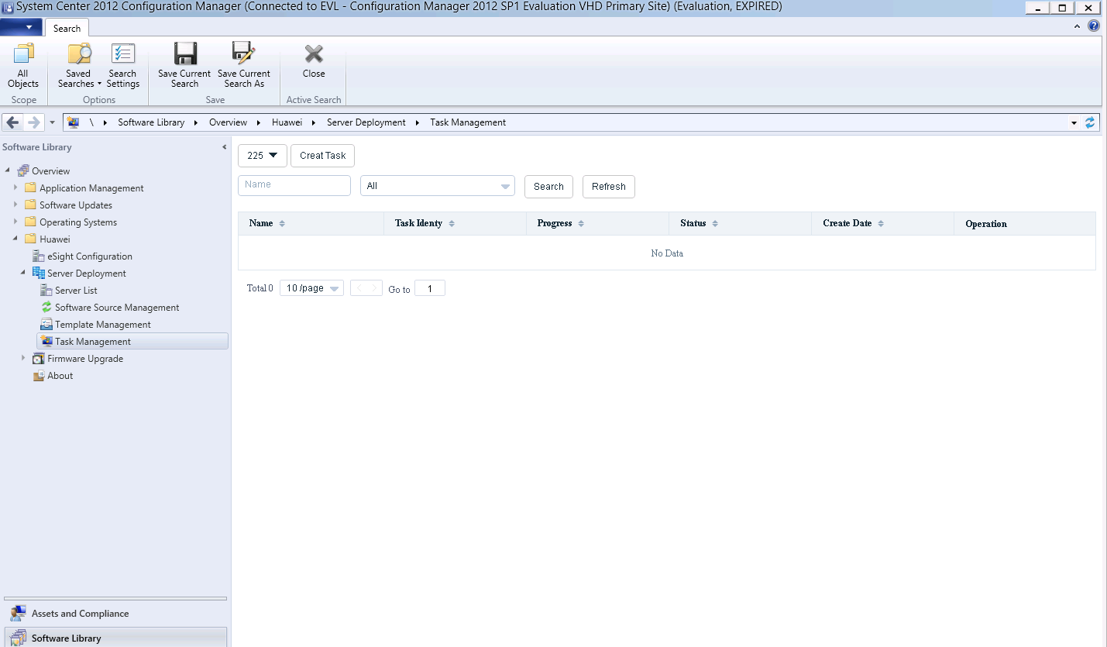

* **225** indicates the customized eSight name. You can select another eSight system from the drop-down list box.
* **All** indicates that all template tasks are to be viewed. You can select another option from the drop-down list box to view specified template tasks. For example, you can select **Complete** to view template tasks that have been executed successfully.

Add a template task.

1. Click **Creat Task**.

The window for creating a template task is displayed, as shown in Figure 3-37.

Creating a template task

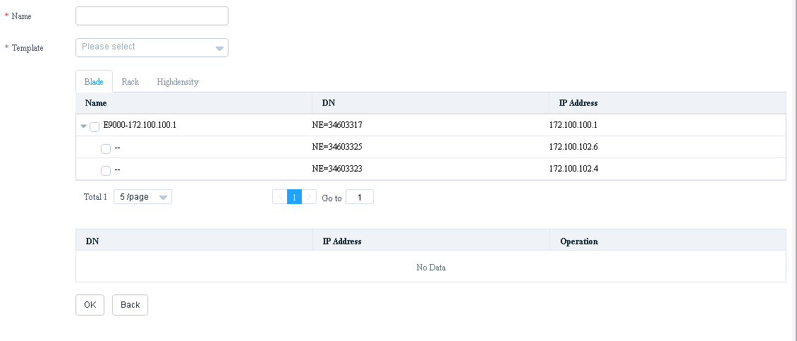

1. Enter task information according to Table 3-7, as shown in Figure 3-38.

Entering task information

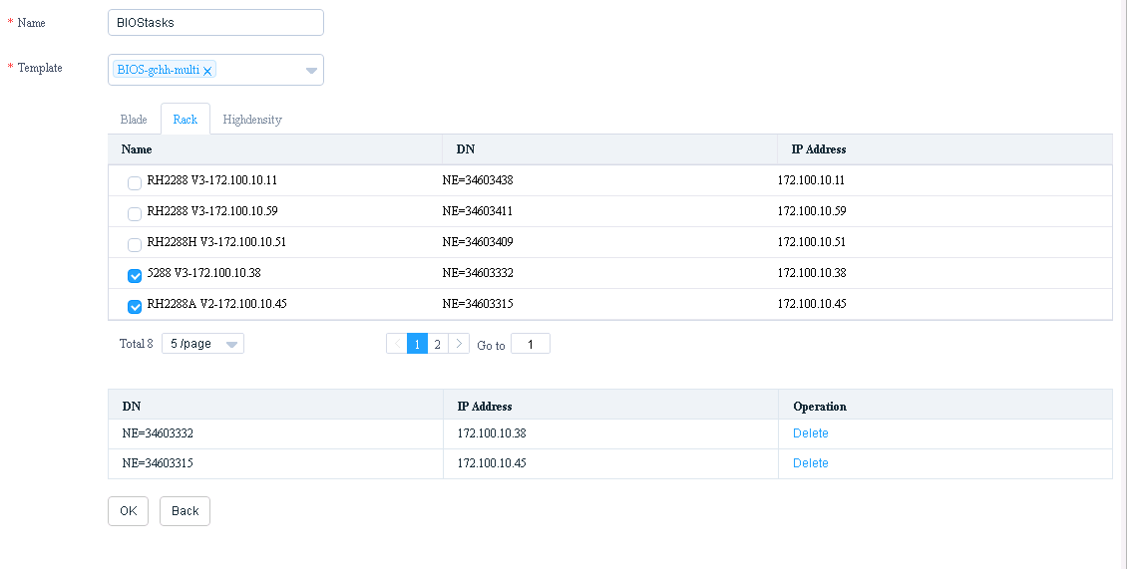

Parameter description

| Parameter | Description | Value | Mandatory |
| --- | --- | --- | --- |
| Name | Task name. | The value contains letters, digits, underscores, and hyphens (**-**). The length ranges from 6 to 32 characters. | Yes |
| Template | Template. | You can select a template that already exists on the eSight. | Yes |
| Selecting a server | - | You can select one or multiple servers of the **Blade**, **Rack**, or **Highdensity** type. | Yes |

1. Click **OK**.

A dialog box indicating successful adding is displayed, as shown in Figure 3-39.

Dialog box



1. Click **OK**.

The **Task Management** window is displayed, as shown in Figure 3-40.

Task Management

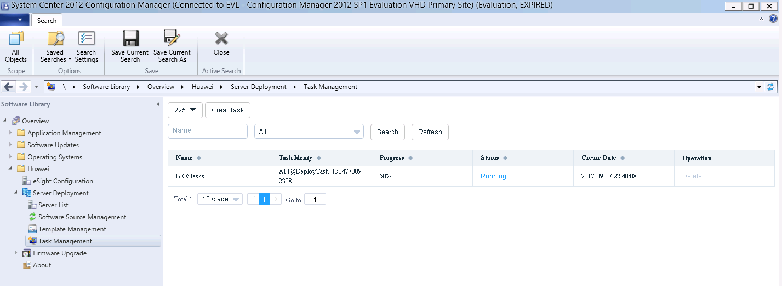

You can view the template task uploading progress and status. **Progress** indicates the uploading progress. **Status** indicates the task status.

1. When the value of **Progress** changes to **100%**, click the value of **Status** of the task.

Detailed task information is displayed, as shown in Figure 3-41.

Detailed task information

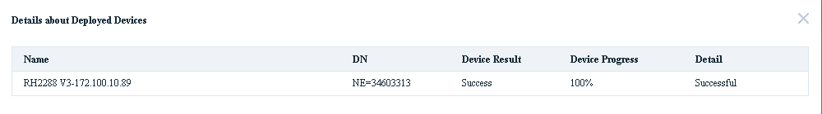

If the value of **Device Result** is **Success**, the template task is executed successfully on the server. If the value of **Device Result** is **Failed**, the template task fails on the server. You can view the value of **Detail** to find the failure causes.

----End

### Configuring a Server

#### Configuring Power Control

Log in to the SCCM server.

Choose **Start** > **Configuration Manager Console** to log in to the SCCM.



If **Configuration Manager Console** cannot be found on the **Start** panel, return to the desktop, right-click **Start**, choose **Search** from the shortcut menu, and enter **Configuration Manager Console** in the search box to find **Configuration Manager Console**.

The SCCM main window is displayed, as shown in Figure 3-42.

SCCM main window



Click **Software Library**.

The **Software Library** window is displayed, as shown in Figure 3-43.

Software Library



Choose **Huawei** > **Server Deployment** > **Template Management**.

The **Template Management** window is displayed, as shown in Figure 3-44.

Template Management



* **225** indicates the customized eSight name. You can select another eSight system from the drop-down list box.
* **All template** indicates that all templates are to be viewed. You can select another option from the drop-down list box to view specified templates. For example, you can select **OS template** to view OS templates.

Click **Create Template**.

The window for creating a template is displayed, as shown in Figure 3-45.

Creating a template



Set **Template Type** to **Power template**.

The window for creating a power control template is displayed, as shown in Figure 3-46.

Creating a power control template

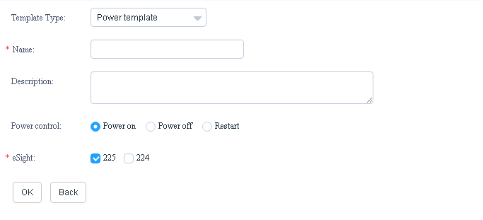

Enter power control template information according to Table 3-8, as shown in Figure 3-47.

Entering power control template information

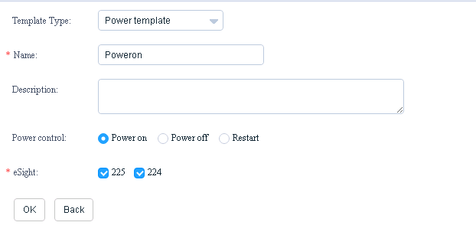

Parameter description

| Parameter | Description | Value | Mandatory |
| --- | --- | --- | --- |
| Name | Template name. | The value contains letters, digits, underscores, and hyphens (**-**). The length ranges from 6 to 32 characters. | Yes |
| Description | Template description. | The value contains 0 to 128 characters. | No |
| Power control | Power control configuration. | The options are as follows:   * Power on * Power off * Restart | Yes |
| eSight | eSight. | You can select one or multiple eSight systems. | Yes |

Click **OK**.

A dialog box indicating successful adding is displayed, as shown in Figure 3-48.

Dialog box



Click **OK**.

The power control template is added successfully, and you can view the added power control template in the template list, as shown in Figure 3-49.

Template list

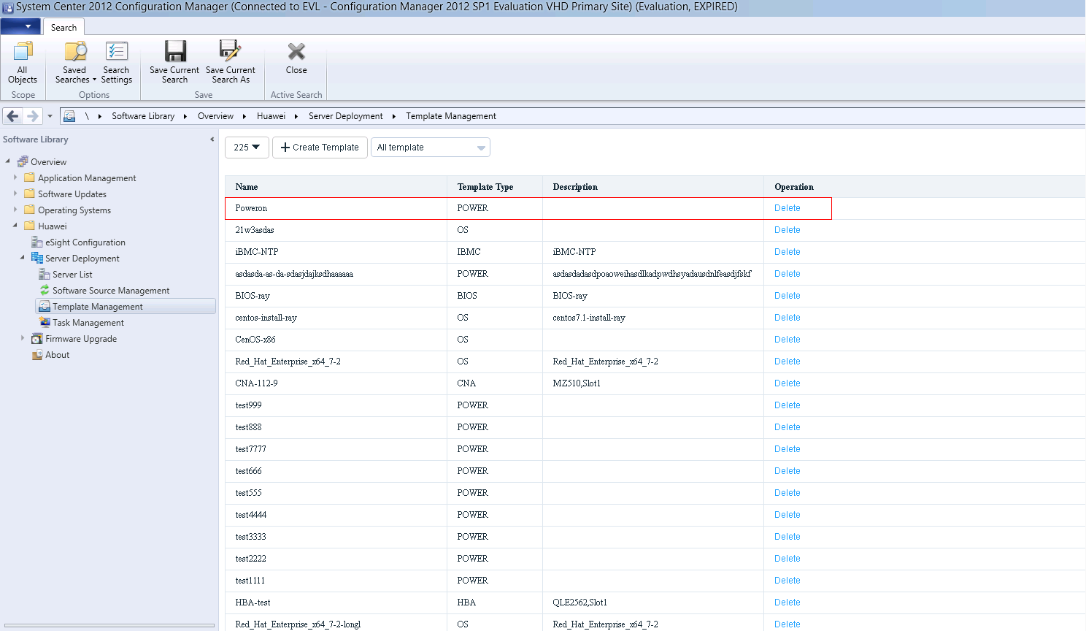

To delete a template, click **Delete** in the row where the template is located.

Add a power control template task according to 3.2.2.3 Adding a Template Task.

----End

#### Configuring the BIOS

Log in to the SCCM server.

Choose **Start** > **Configuration Manager Console** to log in to the SCCM.



If **Configuration Manager Console** cannot be found on the **Start** panel, return to the desktop, right-click **Start**, choose **Search** from the shortcut menu, and enter **Configuration Manager Console** in the search box to find **Configuration Manager Console**.

The SCCM main window is displayed, as shown in Figure 3-50.

SCCM main window



Click **Software Library**.

The **Software Library** window is displayed, as shown in Figure 3-51.

Software Library



Choose **Huawei** > **Server Deployment** > **Template Management**.

The **Template Management** window is displayed, as shown in Figure 3-52.

Template Management



* **225** indicates the customized eSight name. You can select another eSight system from the drop-down list box.
* **All template** indicates that all templates are to be viewed. You can select another option from the drop-down list box to view specified templates. For example, you can select **OS template** to view OS templates.

Click **Create Template**.

The window for creating a template is displayed, as shown in Figure 3-53.

Creating a template



Set **Template Type** to **BIOS template**.

The window for creating a BIOS template is displayed, as shown in Figure 3-54.

Creating a BIOS template

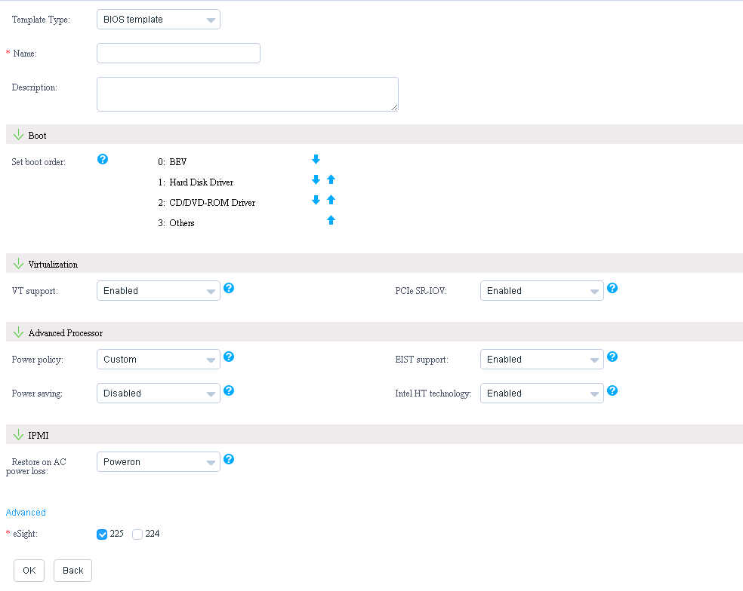

You can click **Advanced** to set more BIOS information. Table 3-9 describes the parameters.

Parameter description

| Module | Parameter | Description | Value | Mandatory |
| --- | --- | --- | --- | --- |
| Basic information | Name | Template name. | The value contains letters, digits, underscores, and hyphens (**-**). The length ranges from 6 to 32 characters. | Yes |
| Description | Template description. | The value contains 0 to 128 characters. | No |
| eSight | eSight. | You can select one or multiple eSight systems. | Yes |
| Boot | Set boot order | System boot sequence. | The value is **0123**. You can click the up and down arrow buttons to change the options corresponding to **0**, **1**, **2**, and **3**.   * BEV * Hard Disk Driver * CD/DVD-ROM Driver * Others | Yes |
| Virtualization | VT support | Enables or disables the hardware-assisted virtualization technology. | The default value is **Enabled**. The options are as follows:   * **Enabled**: enables this technology. * **Disabled**: disables this technology. * **Default**: retains the original value. | No |
| PCIe SR-IOV | Enables or disables the Single Root I/O Virtualization (SR-IOV) technology. With the SR-IOV technology, one PCIe device can export multiple physical PCIe functions or a group of virtual functions that share resources on the I/O device to provide independent memory space, interrupts, and direct memory access (DMA) streams for each VM. | The default value is **Enabled**. The options are as follows:   * **Enabled**: enables this technology. * **Disabled**: disables this technology. * **Default**: retains the original value. | No |
| Advanced Processor | Power policy | Sets the system energy efficiency solution. | The default value is **Custom**. The options are as follows:   * **Efficient**: This solution saves system power. * **Performance**: This solution ensures system performance. * **Custom**: This solution strikes a balance between power saving and performance. * **Default**: retains the original value. | No |
| EIST support | Enables or disables the Enhanced Intel SpeedStep Technology (EIST). When the CPU usage is low, the EIST dynamically reduces the operating frequency of the CPU to minimize system power consumption and heat. When the CPU usage is high, the EIST immediately restores the operating frequency of the CPU to its original value. | The default value is **Enabled**. The options are as follows:   * **Enabled**: enables this technology. * **Disabled**: disables this technology. * **Default**: retains the original value. | No |
| Power saving | Enables or disables the CPU P state adjustment function. This function reduces power consumption by changing the CPU P state. | The default value is **Disabled**. The options are as follows:   * **Enabled**: enables this function. * **Disabled**: disables this function. * **Default**: retains the original value. | No |
| Intel HT technology | Enables or disables the Intel Hyper Threading (HT) technology. This technology enhances CPU performance by increasing the number of CPU kernel threads. | The default value is **Enabled**. The options are as follows:   * **Enabled**: enables this technology. * **Disabled**: disables this technology. * **Default**: retains the original value. | No |
| IPMI | Restore on AC power loss | Sets the restoration mode used by the BMC after AC power-off. | The default value is **Poweron**. The options are as follows:   * **Poweroff**: power-off * **Poweron**: power-on * **Laststate**: last status of the device * **Default**: retains the original value. | No |
| The BIOS information that can be set after you click **Advanced** is as follows. | | | | |
| Boot | Quick Boot | Enables or disables the quick boot mode. This mode skips some check steps in the boot process to shorten the system boot time. | The default value is **Enabled**. The options are as follows:   * **Enabled**: enables this mode. * **Disabled**: disables this mode. * **Default**: retains the original value. | No |
| Quiet Boot | Enables of disables the quiet boot mode. In this mode, the OS is booted by using text. | The default value is **Disabled**. The options are as follows:   * **Enabled**: enables this mode. * **Disabled**: disables this mode. * **Default**: retains the original value. | No |
| Boot Type | Selects a BIOS boot type. The UEFI and Legacy BIOS boot types are supported. | The default value is **LegacyBootType**. The options are as follows:   * **LegacyBootType**: supports only the Legacy mode. * **DualBootType**: supports both the UEFI and Legacy modes. * **UEFIBootType**: supports only the UEFI mode. * **Default**: retains the original value. | No |
| WakeOnLan | Enables or disables the Wake-on-LAN (WOL) function, which wakes up the server using a magic packet. | The default value is **Disabled**. The options are as follows:   * **Enabled**: enables this function. * **Disabled**: disables this function. * **Default**: retains the original value. | No |
| Virtualization | VT-D support | Enables or disables the Intel Virtualization Technology for Directed I/O (VT-D). This technology translates virtual addresses to physical addresses in the virtualization scenario to implement DMA remapping. | The default value is **Enabled**. The options are as follows:   * **Enabled**: enables this technology. * **Disabled**: disables this technology. * **Default**: retains the original value. | No |
| Interrupt remap | Enables or disables the interrupt remap function. This function enables virtual devices to generate different interrupts so that a CPU can process various interrupt signals.  NOTE  This function takes effect only when **VT-D support** is set to **Enabled**. | The default value is **Disabled**. The options are as follows:   * **Enabled**: enables this function. * **Disabled**: disables this function. * **Default**: retains the original value. | No |
| ATS support | Enables or disables the ATS mechanism. The ATS mechanism is provided by the PCIe bus and implemented by the PCIe device. When a PCIe device sends a transaction layer packet (TLP) in address route mode, the address is converted into a host physical address (HPA), thereby relieving VT-D workloads. In addition, the ATS prevents mutual impact between devices in different domains.  NOTE  This function takes effect only when **VT-D support** is set to **Enabled**. | The default value is **Enabled**. The options are as follows:   * **Enabled**: enables this mechanism. * **Disabled**: disables this mechanism. * **Default**: retains the original value. | No |
| Coherency support | Enables or disables the coherency support function.  NOTE  This function takes effect only when **VT-D support** is set to **Enabled**. | The default value is **Disabled**. The options are as follows:   * **Enabled**: enables this function. * **Disabled**: disables this function. * **Default**: retains the original value. | No |
| Pass through DMA support | Enables or disables the DMA pass-through technology.  NOTE  This function takes effect only when **VT-D support** is set to **Enabled**. | The default value is **Enabled**. The options are as follows:   * **Enabled**: enables this technology. * **Disabled**: disables this technology. * **Default**: retains the original value. | No |
| Advanced Processor | Turbo mode | Enables or disables the Turbo mode. This mode allows a CPU to run at a higher frequency than the nominal frequency. | The default value is **Enabled**. The options are as follows:   * **Enabled**: enables this mode. * **Disabled**: disables this mode. * **Default**: retains the original value. | No |
| ACPI version | Advanced Configuration and Power Interface (ACPI) version. The ACPI function manages power for CPUs, batteries, and embedded controllers through the OS to ensure server performance while reducing power consumption. | The default value is **ACPI4.0**. The options are as follows:   * **ACPI1.0B**: 1.0B version * **ACPI3.0**: 3.0 version * **ACPI4.0**: 4.0 version * **Default**: retains the original value. | No |
| NUMA | Enables or disables the Non-Uniform Memory Access Architecture (NUMA) technology. This technology effectively expands the system scale by enabling multiple servers to run like a single system while enabling the system to be programmable and manageable. | The default value is **Enabled**. The options are as follows:   * **Enabled**: enables this technology. * **Disabled**: disables this technology. * **Default**: retains the original value. | No |
| C-states | Enables or disables the CPU C-state function. This function is an in-depth energy-saving technology. C-states such as C3, C6, and C7 indicate energy-saving effect and CPU recovery time in ascending order. After the C-state function is enabled, you need to set **OS ACPI Cx**, **Enhanced C-state**, **Enable C3**, **Enable C6**, and **Enable C7**. | The default value is **Enabled**. The options are as follows:   * **Enabled**: enables this function. * **Disabled**: disables this function. * **Default**: retains the original value. | No |
| RasMode | The memory reliability, availability, and serviceability (RAS) function enhances the error correction capability of the memory to improve memory reliability and data accuracy. | The default value is **Independent**. The options are as follows:   * **Independent**: Each channel works independently. The data on each cache line is from the same channel. * **Mirror**: creates an image for the memory. * **LockStep**: Two memory channels work at the same pace. Two physical channels constitute a logical channel. * **RankSpare**: Memory backup is performed by rank. * **LockStepAndRankSpare**: The **LockStep** and **RankSpare** modes are supported at the same time. * **Default**: retains the original value. | No |
| OS ACPI Cx | ACPI C-state of the OS. The OS instructs a CPU to enter the C-state based on the ACPI C-state.  NOTE  This function takes effect only when **C-states** is set to **Enabled**. | The default value is **ACPI C3**. The options are as follows:   * ACPI C3 * ACPI C2 * **Default**: retains the original value. | No |
| MLC spatial prefetcher | Enables or disables the Mid Level Cache (MLC) spatial prefetcher function. This function prefetches two high-speed cache storage devices (128 bytes). The reading time is twice the common prefetching time. | The default value is **Enabled**. The options are as follows:   * **Enabled**: enables this function. * **Disabled**: disables this function. * **Default**: retains the original value. | No |
| Enhanced C-state | Enables or disables the enhanced C-state function. This function enables the P-state to change with the C-state.  NOTE  This function takes effect only when **C-states** is set to **Enabled**. | The default value is **Enabled**. The options are as follows:   * **Enabled**: enables this function. * **Disabled**: disables this function. * **Default**: retains the original value. | No |
| MLC streamer prefetcher | Enables or disables the MLC streamer prefetcher function. This function prefetches CPU instructions to reduce the instruction reading time. | The default value is **Enabled**. The options are as follows:   * **Enabled**: enables this function. * **Disabled**: disables this function. * **Default**: retains the original value. | No |
| Enable C3 | Enables or disables C3. C3 indicates that all internal CPU clocks, including the bus interface and APIC, are disabled.  NOTE  This function takes effect only when **C-states** is set to **Enabled**. | The default value is **Disabled**. The options are as follows:   * **Enabled**: enables this function. * **Disabled**: disables this function. * **Default**: retains the original value. | No |
| DCU IP prefetcher | Enables or disables the data cache unit (DCU) IP prefetcher function. This function determines whether to prefetch data based on historical records to shorten the data reading time. | The default value is **Enabled**. The options are as follows:   * **Enabled**: enables this function. * **Disabled**: disables this function. * **Default**: retains the original value. | No |
| Enable C6 | Enables or disables C6. C6 indicates that the CPU voltage is reduced to 0.  NOTE  This function takes effect only when **C-states** is set to **Enabled**. | The default value is **Disabled**. The options are as follows:   * **Enabled**: enables this function. * **Disabled**: disables this function. * **Default**: retains the original value. | No |
| DCU streamer prefetcher | Enables or disables the DCU streamer prefetcher function. This function prefetches CPU data to shorten the data reading time. | The default value is **Enabled**. The options are as follows:   * **Enabled**: enables this function. * **Disabled**: disables this function. * **Default**: retains the original value. | No |
| Enable C7 | Enables or disables C7. C7 indicates that only the LLC is retained.  NOTE  This function takes effect only when **C-states** is set to **Enabled**. | The default value is **Disabled**. The options are as follows:   * **Enabled**: enables this function. * **Disabled**: disables this function. * **Default**: retains the original value. | No |
| Console Serial Port | Console serial redirect | Specifies whether to map data on a specified physical or virtual serial port to the system serial port. | The default value is **Enabled**. The options are as follows:   * **Enabled**: enables this function. * **Disabled**: disables this function. * **Default**: retains the original value. | No |
| Terminal type | Protocol type used by the terminal with a serial port.  NOTE  This function takes effect only when **Console serial redirect** is set to **Enabled**. | The default value is **PC_ANSI**. The options are as follows:   * VT_100 * Vt_100+ * VT_UTF8 * PC_ANSI * **Default**: retains the original value. | No |
| Parity | Specifies whether to enable the parity check function. This function verifies code transmission accuracy.  NOTE  This function takes effect only when **Console serial redirect** is set to **Enabled**. | The default value is **None**. The options are as follows:   * None * Even * Odd * **Default**: retains the original value. | No |
| Baud rate | Specifies the baud rate of a serial port. The baud rate indicates the number of bits transmitted per second.  NOTE  This function takes effect only when **Console serial redirect** is set to **Enabled**. | The default value is **115200**. The options are as follows:   * 115200 * 57600 * 19200 * 9600 * **Default**: retains the original value. | No |
| Stop bits | Specifies the number of stop bits in a single data packet. If the number of stop bits is larger, the system is more tolerant to different clock synchronization but the data transmission rate is lower.  NOTE  This function takes effect only when **Console serial redirect** is set to **Enabled**. | The default value is **1**. The options are as follows:   * 1 * 2 * **Default**: retains the original value. | No |
| Data bits | Specifies the data bit width of a serial port, which indicates the actual number of data bits during communication.  NOTE  This function takes effect only when **Console serial redirect** is set to **Enabled**. | The default value is **8**. The options are as follows:   * 7 * 8 * **Default**: retains the original value. | No |
| IPMI | BMC WDT support for OS | Specifies whether to enable the watchdog timer (WDT) to perform the specified action if the OS startup times out. The watchdog requires the OS watchdog driver; otherwise, an OS startup exception may occur. | The default value is **Disabled**. The options are as follows:   * **Enabled**: enables this function. * **Disabled**: disables this function. * **Default**: retains the original value. | No |
| BMC WDT time out for OS(min) | Sets the maximum waiting time for the WDT during the OS startup process. The unit is minute.  NOTE  This function takes effect only when **BMC WDT support for OS** is set to **Enabled**. | The default value is **5**. The options are as follows:   * 2 * 3 * 4 * 5 * 6 * 7 * 8 * **Default**: retains the original value. | No |
| BMC WDT action for OS | WDT response mode after the OS startup times out.  NOTE  This function takes effect only when **BMC WDT support for OS** is set to **Enabled**. | The default value is **5**. The options are as follows:   * **No Action**: The WDT performs no operation. * **Hard Reset**: The WDT forcibly resets the system. * **Power Down**: The WDT powers off the system. * **Power Cycle**: The WDT attempts to start the OS repeatedly until the OS is accessed properly. * **Default**: retains the original value. | No |

Enter BIOS template information according to Table 3-9, as shown in Figure 3-55.

Entering BIOS template information

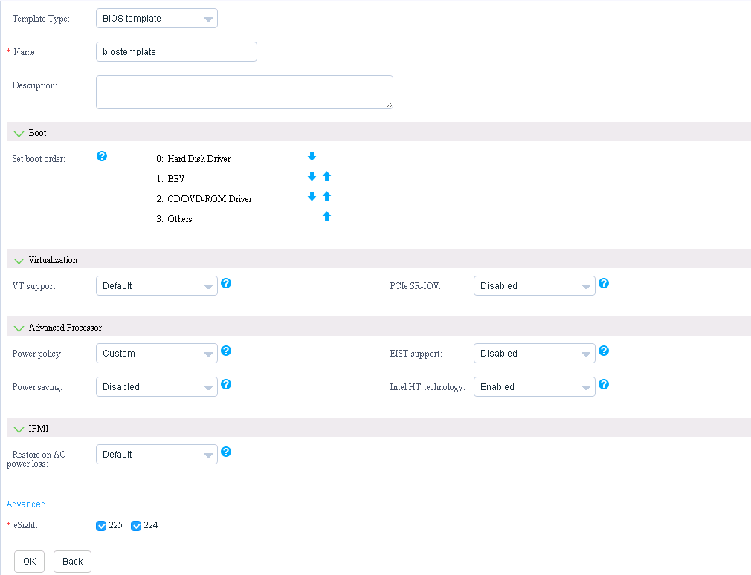

Click **OK**.

A dialog box indicating successful adding is displayed, as shown in Figure 3-56.

Dialog box



Click **OK**.

The BIOS template is added successfully, and you can view the added BIOS template in the template list, as shown in Figure 3-57.

Template list

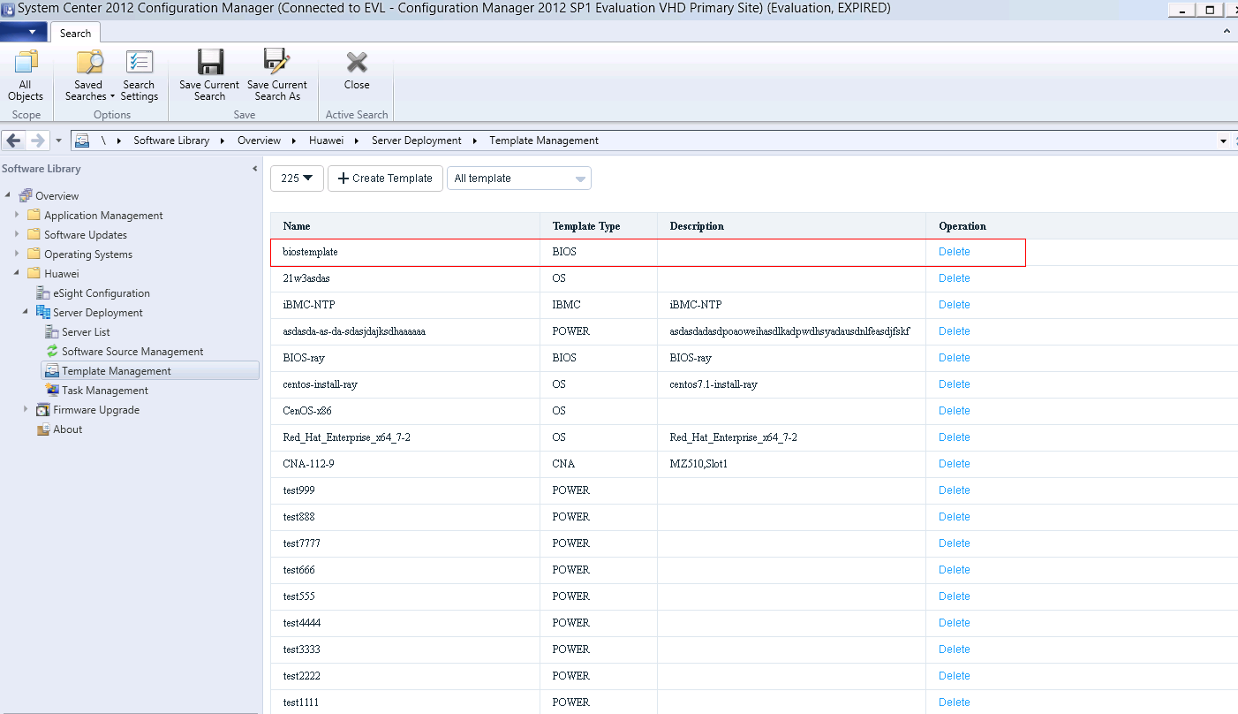

To delete a template, click **Delete** in the row where the template is located.

Add a BIOS template task according to 3.2.2.3 Adding a Template Task.

----End

#### Configuring an HBA

Log in to the SCCM server.

Choose **Start** > **Configuration Manager Console** to log in to the SCCM.



If **Configuration Manager Console** cannot be found on the **Start** panel, return to the desktop, right-click **Start**, choose **Search** from the shortcut menu, and enter **Configuration Manager Console** in the search box to find **Configuration Manager Console**.

The SCCM main window is displayed, as shown in Figure 3-58.

SCCM main window



Click **Software Library**.

The **Software Library** window is displayed, as shown in Figure 3-59.

Software Library



Choose **Huawei** > **Server Deployment** > **Template Management**.

The **Template Management** window is displayed, as shown in Figure 3-60.

Template Management



* **225** indicates the customized eSight name. You can select another eSight system from the drop-down list box.
* **All template** indicates that all templates are to be viewed. You can select another option from the drop-down list box to view specified templates. For example, you can select **OS template** to view OS templates.

Click **Create Template**.

The window for creating a template is displayed, as shown in Figure 3-61.

Creating a template



Set **Template Type** to **HBA template**.

The window for creating an HBA template is displayed, as shown in Figure 3-62.

Creating an HBA template

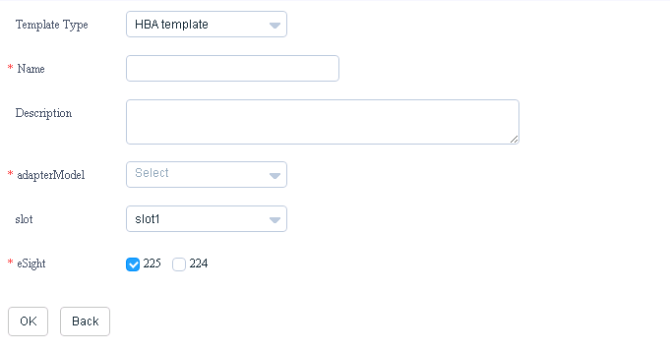

Enter HBA template information according to Table 3-10, as shown in Figure 3-63.

Entering HBA template information

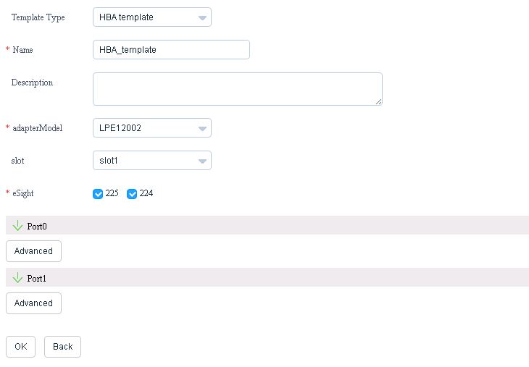

Parameter description

| Parameter | Description | Value | Mandatory |
| --- | --- | --- | --- |
| Name | Template name. | The value contains letters, digits, underscores, and hyphens (**-**). The length ranges from 6 to 32 characters. | Yes |
| Description | Template description. | The value contains 0 to 128 characters. | No |
| adapterModel | HBA model. | The options are as follows:   * LPE12000 * LPE12002 * LPE16000 * LPE16002 * QLE2560 * QLE2562 * QLE2670 * QLE2672 * MZ220 | Yes |
| slot | HBA slot. | Slots 1 to 8 | Yes |
| eSight | eSight. | You can select one or multiple eSight systems. | Yes |
| Port0 | Configures physical port 0 for the adapter. This parameter is used to configure whether the OS is started from SAN. If the SAN Boot function is enabled, you also need to set the target WWPN, target WWNN, and target LUN related to the system startup. The three items with the same priority take effect only when they are set at the same time. | For details, see Table 3-11. | Yes |
| Port1 | Configures physical port 1 for the adapter. This parameter is used to configure whether the OS is started from SAN. If the SAN Boot function is enabled, you also need to set the target WWPN, target WWNN, and target LUN related to the system startup. The three items with the same priority take effect only when they are set at the same time. | For details, see Table 3-11. | This parameter is mandatory if **adapterModel** is set to **LPE12002**, **LPE16002**, **QLE2562**, **MZ220**, or **QLE2672**. |

Port 0 and port 1 parameter description

| Parameter | Description | Value | Mandatory |
| --- | --- | --- | --- |
| SANBoot | Enables or disables the SAN Boot function. | * **Enabled**: enables this function. * **Disabled**: disables this function. | Yes |
| Target0 to Target7 | Target configuration information related to system startup corresponding to priorities 0 to 7. This parameter takes effect only when the SAN Boot function is enabled. Target0 has the highest priority, and Target7 has the lowest priority.  NOTE   * Target0 to Target7 are used if the HBA model is LPE12000, LPE12002, LPE16000, LPE16002, or MZ220. * Target0 to Target3 are used if the HBA model is QLE2560, QLE2562, QLE2670, or QLE2672. | * If the HBA model is LPE12000, LPE12002, LPE16000, LPE16002, or MZ220, the configuration takes effect only when the target WWPN and target LUN of the same priority are set at the same time. * If the HBA model is QLE2560, QLE2562, QLE2670, or QLE2672, the configuration takes effect only when the target WWPN, target WWNN, and target LUN of the same priority are set at the same time. | Yes |
| TargetWWPN | Target WWPN. | The format is **XX:XX:XX:XX:XX:XX:XX:XX**. **X** indicates a hexadecimal integer. | No |
| TargetWWNN | Target WWNN. | The format is **XX:XX:XX:XX:XX:XX:XX:XX**. **X** indicates a hexadecimal integer. | No |
| TargetLUN | Target LUN to be scanned. If the target LUN contains system files, the OS starts from the LUN. | An integer ranging from 0 to 255 | No |

Click **OK**.

A dialog box indicating successful adding is displayed, as shown in Figure 3-64.

Dialog box



Click **OK**.

The HBA template is added successfully, and you can view the added HBA template in the template list, as shown in Figure 3-65.

Template list

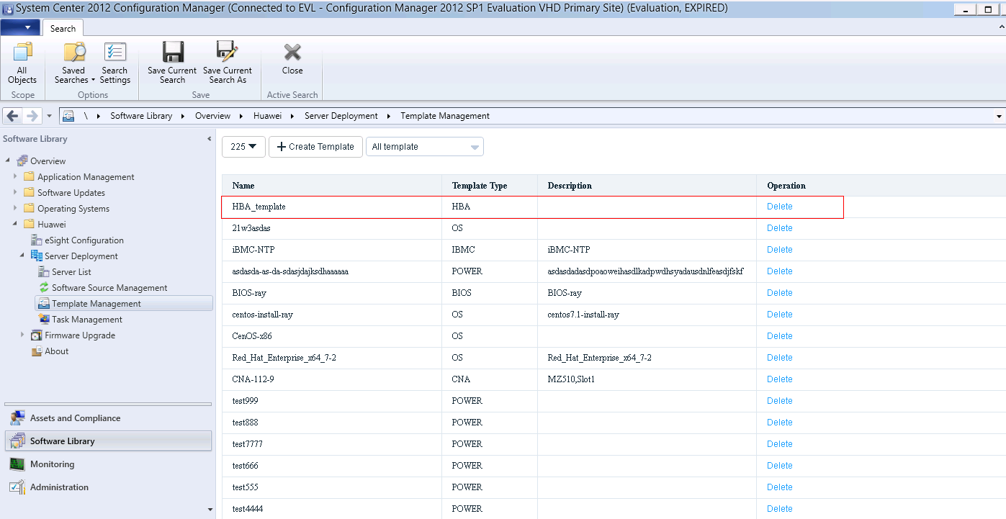

To delete a template, click **Delete** in the row where the template is located.

Add an HBA template task according to 3.2.2.3 Adding a Template Task.

----End

#### Configuring RAID

Log in to the SCCM server.

Choose **Start** > **Configuration Manager Console** to log in to the SCCM.



If **Configuration Manager Console** cannot be found on the **Start** panel, return to the desktop, right-click **Start**, choose **Search** from the shortcut menu, and enter **Configuration Manager Console** in the search box to find **Configuration Manager Console**.

The SCCM main window is displayed, as shown in Figure 3-66.

SCCM main window



Click **Software Library**.

The **Software Library** window is displayed, as shown in Figure 3-67.

Software Library



Choose **Huawei** > **Server Deployment** > **Template Management**.

The **Template Management** window is displayed, as shown in Figure 3-68.

Template Management



* **225** indicates the customized eSight name. You can select another eSight system from the drop-down list box.
* **All template** indicates that all templates are to be viewed. You can select another option from the drop-down list box to view specified templates. For example, you can select **OS template** to view OS templates.

Click **Create Template**.

The window for creating a template is displayed, as shown in Figure 3-69.

Creating a template



Set **Template Type** to **RAID template**.

The window for creating a RAID template is displayed, as shown in Figure 3-70.

Creating a RAID template

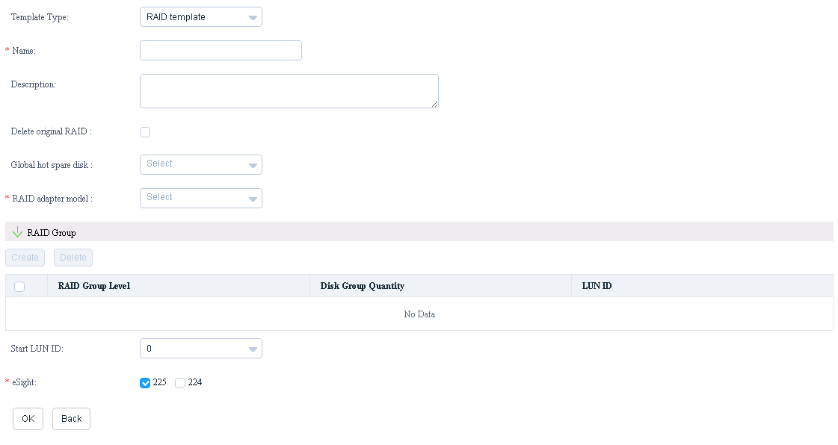

Enter RAID template information according to Table 3-12, as shown in Figure 3-71.

Entering RAID template information

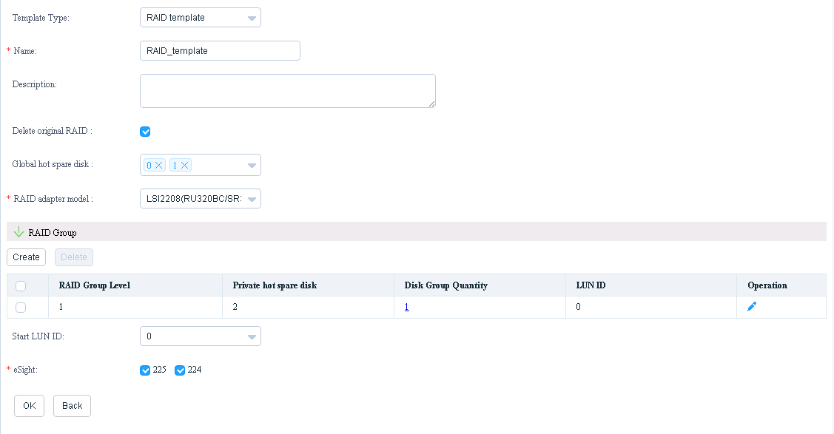

Parameter description

| Parameter | Description | Value | Mandatory |
| --- | --- | --- | --- |
| Name | Template name. | The value contains letters, digits, underscores, and hyphens (**-**). The length ranges from 6 to 32 characters. | Yes |
| Description | Template description. | The value contains 0 to 128 English characters. | No |
| Delete original RAID | Whether to delete the original RAID configuration from the device. | If this parameter is selected, the original RAID configuration will be deleted. If this parameter is deselected, the original RAID configuration will not be deleted. | Yes |
| Global hot spare disk | Slot of the global hot spare disk. | This parameter is left empty by default. You can select one or several from **0** to **26**.  NOTE  The slots selected for **Global hot spare disk**, **Private hot spare disk**, and **Disk group** cannot be duplicated. | No |
| RAID adapter model | RAID controller card model. | * **LSI SAS2308**: RAID controller card of the SR120 or RU120 model. * **LSI SAS2208**: RAID controller card of the RU320BC, SR320, SR520, or SR420 model. * **LSI SAS3008**: RAID controller card of the SR130 or RU130 model. * **LSI SAS3108**: RAID controller card of the SR430C or RU430C model. | Yes |
| RAID Group | RAID group. | You can click **Create** to create a RAID group. For details about RAID group configuration, see Table 3-13.  NOTE  At least one RAID group needs to be created. Multiple RAID groups can be created. Up to two RAID groups can be created for LSI SAS2308 and LSI SAS3008 RAID controller cards, and a maximum of 14 hard disks can be selected. Up to 64 RAID groups can be created for LSI SAS2208 and LSI SAS3108 RAID controller cards. | Yes |
| Start LUN ID | Starting LUN ID. | The default value is **0**. The plug-in will automatically number RAID groups or customized LUNs, starting from 0. The starting LUN ID cannot be larger than the maximum number. | No |
| eSight | eSight. | You can select one or multiple eSight systems. | Yes |

RAID group parameter description

| Parameter | Description | Value | Mandatory |
| --- | --- | --- | --- |
| RAID level | RAID group type. | The options are as follows:   * RAID0 * RAID1 * RAID5 * RAID6 * RAID1E * RAID10 * RAID50 * RAID60   NOTE   * LSI SAS2308 and LSI SAS3008 RAID controller cards support RAID 0, RAID 1, RAID 10, and RAID 1E. * LSI SAS2208 and LSI SAS3108 RAID controller cards support RAID 0, RAID 1, RAID 5, RAID 6, RAID 10, RAID 50, and RAID 60. | Yes |
| Private hot spare disk | Slot of the private hot spare disk. | This parameter is left empty by default. You can select one or several from **0** to **26**.  NOTE   * The slots selected for **Global hot spare disk**, **Private hot spare disk**, and **Disk group** cannot be duplicated. * Private hot spare disks cannot be configured for LSI SAS2308 and LSI SAS3008 RAID controller cards. * Private hot spare disks cannot be configured for RAID 0. | No |
| Disk group | Slot of the hard disk group. | This parameter is left empty by default. You can select one or several from **0** to **26**.  NOTE   * The slots selected for **Global hot spare disk**, **Private hot spare disk**, and **Disk group** cannot be duplicated. * You can create only one hard disk group for RAID 0, RAID 1, RAID 5, RAID 6, or RAID 1E. * You need to select at least one hard disk for RAID 0. * You need to select at least two hard disks for RAID 0 of LSI SAS2308 and LSI SAS3008. * Only two hard disks can be configured for RAID 1. * At least three hard disks are required for RAID 1E. The number of hard disks must be an odd number. * At least three hard disks are required for RAID 5. * At least four hard disks are required for RAID 6. * The number of RAID 10 hard disk groups ranges from 2 to 8. Each group contains two hard disks. * At least six hard disks must be configured for RAID 50. The number of required hard disk groups ranges from 2 to 8. Each group contains at least three hard disks, and the number of hard disks in each group must be the same. * At least eight hard disks must be configured for RAID 60. The number of required hard disk groups ranges from 2 to 8. Each group contains at least four hard disks, and the number of hard disks in each group must be the same. | Yes |
| The following parameters can be set only after a RAID group is created. You can click in the row of the RAID group to set the following parameters. | | | |
| WritePolicy | Write policy. | * **WriteBack**: Write back policy. This is the default value. * **WriteThrough**: Write through policy.   NOTE  This attribute is not supported by LSI SAS2308 and LSI SAS3008 RAID controller cards. | No |
| ReadPolicy | Read policy. | * **Normal prefetch**: Normal prefetch policy. This is the default value. * **No prefetch**: No prefetch policy.   NOTE  This attribute is not supported by LSI SAS2308 and LSI SAS3008 RAID controller cards. | No |
| I/O policy | Cache policy. | * **High-speed cache**: High-speed cache policy. This is the default value. * **Direct**: Direct cache policy.   NOTE  This attribute is not supported by LSI SAS2308 and LSI SAS3008 RAID controller cards. | No |
| Division mode | Whether LUN partitioning is customized. | * **Custom**: Yes. * **Default**: No.   NOTE  This attribute is not supported by LSI SAS2308 and LSI SAS3008 RAID controller cards. | Yes |
| The following parameters need to be set if **Division mode** is set to **Custom**. | | | |
| Capacity(MB) | LUN capacity. | The unit is MB. For example, **10000;20000;MAXSIZE**. **MAXSIZE** indicates the remaining capacity.  NOTE   * Each RAID group can be divided into a maximum of 64 LUNs. * The total capacity of LUN partitions cannot be greater than 96 TB, that is, 100663296 MB. | No |
| Use available capacity | Use of the remaining capacity. | If **Use available capacity** is selected, the partition will use the remaining capacity. | No |

Click **OK**.

A dialog box indicating successful adding is displayed, as shown in Figure 3-72.

Dialog box



Click **OK**.

The RAID template is added successfully, and you can view the added RAID template in the template list, as shown in Figure 3-73.

Template list

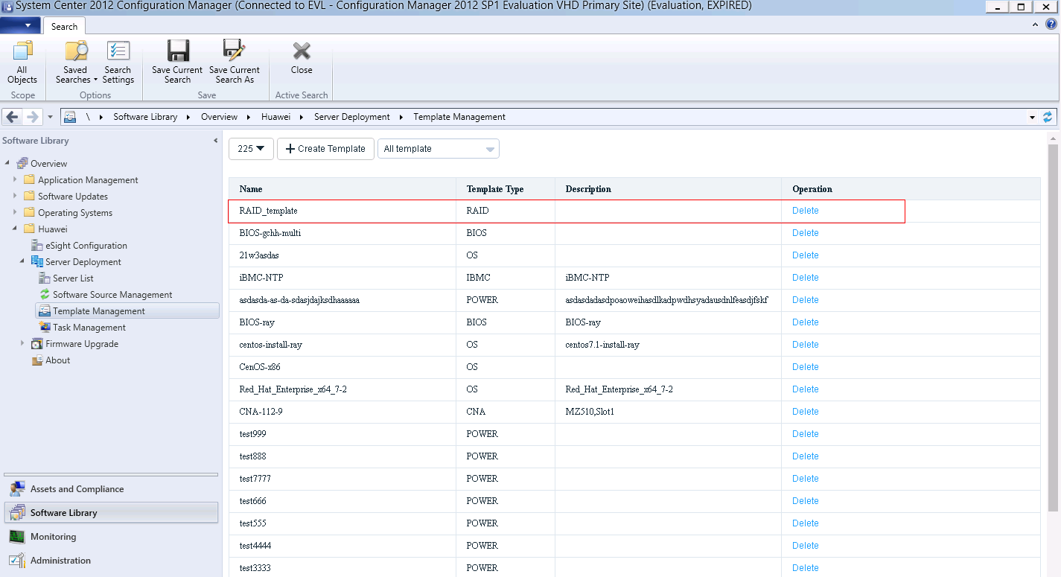

To delete a template, click **Delete** in the row where the template is located.

Add a RAID template task according to 3.2.2.3 Adding a Template Task.

----End

#### Configuring a CNA

Log in to the SCCM server.

Choose **Start** > **Configuration Manager Console** to log in to the SCCM.



If **Configuration Manager Console** cannot be found on the **Start** panel, return to the desktop, right-click **Start**, choose **Search** from the shortcut menu, and enter **Configuration Manager Console** in the search box to find **Configuration Manager Console**.

The SCCM main window is displayed, as shown in Figure 3-74.

SCCM main window



Click **Software Library**.

The **Software Library** window is displayed, as shown in Figure 3-75.

Software Library



Choose **Huawei** > **Server Deployment** > **Template Management**.

The **Template Management** window is displayed, as shown in Figure 3-76.

Template Management



* **225** indicates the customized eSight name. You can select another eSight system from the drop-down list box.
* **All template** indicates that all templates are to be viewed. You can select another option from the drop-down list box to view specified templates. For example, you can select **OS template** to view OS templates.

Click **Create Template**.

The window for creating a template is displayed, as shown in Figure 3-77.

Creating a template



Set **Template Type** to **CNA template**.

The window for creating a CNA template is displayed, as shown in Figure 3-78.

Creating a CNA template

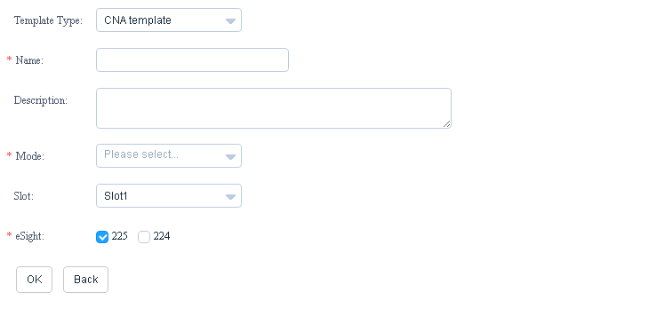

Enter CNA template information according to Table 3-14, as shown in Figure 3-79.

Entering CNA template information

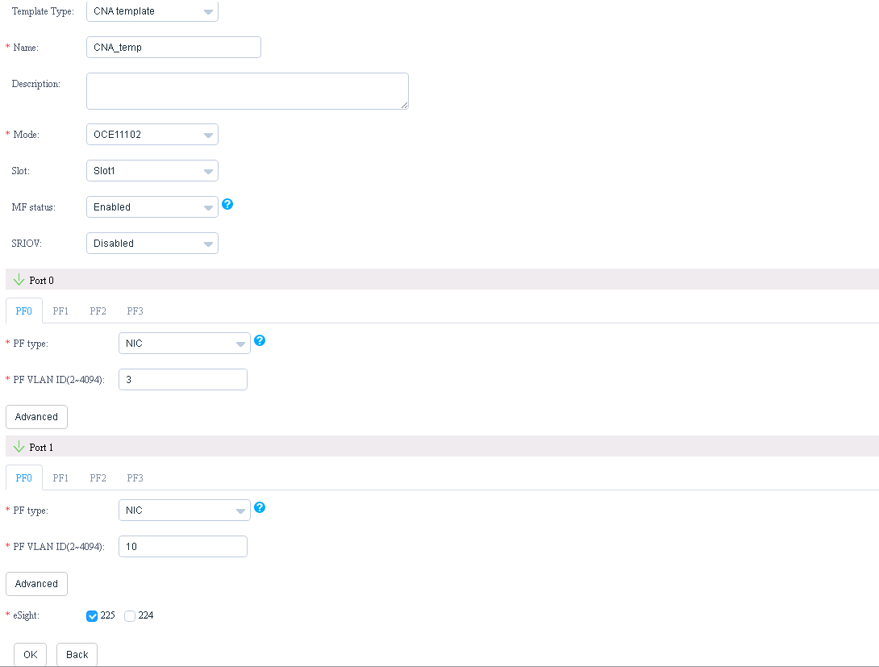

Parameter description

| Parameter | Description | Value | Mandatory |
| --- | --- | --- | --- |
| Name | Template name. | The value contains letters, digits, underscores, and hyphens (**-**). The length ranges from 6 to 32 characters. | Yes |
| Description | Template description. | The value contains 0 to 128 characters. | No |
| Mode | CNA model. | * OCE11102 * MZ510 * MZ512 * MZ910 | Yes |
| slot | CNA slot. | Slots 1 to 8 | Yes |
| MF status | The MF function supports multi-channel PF (one PF indicates one logical channel). After this function is enabled, a physical port will be divided into four logical channels. Each logical channel can be set to a NIC, FCoE, or iSCSI port. | The default value is **Enabled**. The options are as follows:   * **Enabled**: enables this function. * **Disabled**: disables this function.   NOTE   * If **MF status** is set to **Disabled**, all physical ports include only one logical channel. * **MF status** and **SRIOV** cannot be enabled at the same time. * This attribute is not involved when **Mode** is set to **MZ910**. | No |
| SRIOV | Single-channel cache virtualization function. | The default value is **Disabled**. The options are as follows:   * **Enabled**: enables this function. * **Disabled**: disables this function.   NOTE   * **MF status** and **SRIOV** cannot be enabled at the same time. * This attribute is not involved when **Mode** is set to **MZ910**. | No |
| Port0 to Port3 | Port configuration. | Port0 to Port3. For details about the configuration of a single port, see Table 3-15.  NOTE   * Port0 and Port1 need to be configured when **Mode** is set to **OCE11102** or **MZ510**. * Port0 to Port3 need to be configured when **Mode** is set to **MZ512** or **MZ910**. | Yes |
| eSight | eSight. | You can select one or multiple eSight systems. | Yes |

Port0 to Port3 configuration description

| Parameter | Description | Value | Mandatory |
| --- | --- | --- | --- |
| PF0 to PF3 | PF logical channel attribute. | PF0 to PF3. For details about the configuration of a single PF, see Table 3-16 and Table 3-17.  NOTE   * PF0 to PF3 need to be configured when **Mode** is set to **OCE11102**, **MZ510**, or **MZ512** and **MF status** is set to **Enabled**. * PF0 needs to be configured when **Mode** is set to **OCE11102**, **MZ510**, or **MZ512** and **MF status** is set to **Disabled**. * This attribute is not involved when **Mode** is set to **MZ910**. | Yes |
| PXE boot | Enables or disables the PXE Boot function. | The default value is **Enabled**. The options are as follows:   * **Enabled**: enables this function. * **Disabled**: disables this function.   NOTE  Only physical ports and Port0 and Port1 of the MZ910 involve this parameter. | Yes |
| SAN boot | Enables or disables the SAN Boot function. | The default value is **Enabled**. The options are as follows:   * **Enabled**: enables this function. * **Disabled**: disables this function.   NOTE  Only physical ports and Port2 and Port3 of the MZ910 involve this parameter. | Yes |
| Target0 to Target7 | Target configuration information related to system startup corresponding to priorities 0 to 7. This parameter takes effect only when the SAN Boot function is enabled. Target0 has the highest priority, and Target7 has the lowest priority. | Value range:   * **TargetWWPN**: The format is **XX:XX:XX:XX:XX:XX:XX:XX**. **X** indicates a hexadecimal integer. * **Target LUN ID**: The value is an integer ranging from 0 to 255.   NOTE   * The target LUN indicates the LUN to be scanned. If the target LUN contains system files, the OS starts from the LUN. * The configuration takes effect only when the target WWPN and target LUN of the same priority are set at the same time. * Only physical ports and Port2 and Port3 of the MZ910 involve this parameter, and **SAN boot** needs to be set to **Enabled**. | No |

PF0, PF2, and PF3 configuration description

| Parameter | Description | Value | Mandatory |
| --- | --- | --- | --- |
| PFType | Type of the virtual port. | The value must be **NIC**. | No |
| PF VLAN ID | VLAN ID. | Value range: 2 to 4094  NOTE  PF VLAN IDs cannot be duplicated. | Yes |
| Min. bandwidth ratio | Minimum bandwidth ratio of a single virtual network port. | The default value is **25**. The value is an integer ranging from 1 to 100.  NOTE  The total of the minimum bandwidth ratios of all virtual ports of the same physical port must be 100. | No |
| Max. bandwidth ratio | Maximum bandwidth ratio of a single virtual network port. | The default value is **100**. The value is an integer ranging from 1 to 100. | No |
| PXE boot | Enables or disables the PXE Boot function. | The default value is **Disabled**. The options are as follows:   * **Enabled**: enables this function. * **Disabled**: disables this function.   NOTE  Only PF0 involves this parameter. | No |

PF1 configuration description

| Parameter | Description | Value | Mandatory |
| --- | --- | --- | --- |
| PFType | Type of the virtual port. | The default value is **NIC**. The options are as follows:   * NIC * iSCSI * FCoE | No |
| PF VLAN ID | VLAN ID. | * The value ranges from 2 to 4094 if **PFType** is set to **NIC**. * The value must be **0** if **PFType** is set to **iSCSI** or **FCoE**.   NOTE  PF VLAN IDs cannot be duplicated. | Yes |
| Min. bandwidth ratio | Minimum bandwidth ratio of a single virtual network port. | The default value is **25**. The value is an integer ranging from 1 to 100.  NOTE  The total of the minimum bandwidth ratios of all virtual ports of the same physical port must be 100. | No |
| Max. bandwidth ratio | Maximum bandwidth ratio of a single virtual network port. | The default value is **100**. The value is an integer ranging from 1 to 100. | No |
| iSCSI Boot | Enables or disables the iSCSI Boot function. | The default value is **Disabled**. The options are as follows:   * **Enabled**: enables this function. * **Disabled**: disables this function.   NOTE  This parameter is involved only when **PFType** is set to **iSCSI**. | No |
| Network | Network configuration. | For details about the network configuration, see Table 3-18.  NOTE  This parameter is involved only when **PFType** is set to **iSCSI**. | Yes |
| Initiaor | Initiator configuration. | For details about the initiator configuration, see Table 3-19.  NOTE  This parameter is involved only when **PFType** is set to **iSCSI**. | Yes |
| Target | Target configuration. | For details about the target configuration, see Table 3-20.  NOTE  This parameter is involved only when **PFType** is set to **iSCSI**. | No |
| SAN boot | Enables or disables the SAN Boot function. | The default value is **Enabled**. The options are as follows:   * **Enabled**: enables this function. * **Disabled**: disables this function.   NOTE  This parameter is involved only when **PFType** is set to **FCoE**. | No |
| Target0 to Target7 | Target configuration information related to system startup corresponding to priorities 0 to 7. This parameter takes effect only when the SAN Boot function is enabled. Target0 has the highest priority, and Target7 has the lowest priority. | Value range:   * **TargetWWPN**: The format is **XX:XX:XX:XX:XX:XX:XX:XX**. **X** indicates a hexadecimal integer. * **Target LUN ID**: The value is an integer ranging from 0 to 255.   NOTE   * This parameter is involved only when **PFType** is set to **FCoE**. * The target LUN indicates the LUN to be scanned. If the target LUN contains system files, the OS starts from the LUN. * The configuration takes effect only when the target WWPN and target LUN of the same priority are set at the same time. | No |

Network configuration description

| Parameter | Description | Value | Mandatory |
| --- | --- | --- | --- |
| VLAN | VLAN function. | The default value is **Disabled**. The options are as follows:   * **Enabled**: enables this function. * **Disabled**: disables this function. | No |
| VLANID | VLAN ID. | The value is an integer ranging from 0 to 4094.  NOTE  This parameter is involved only when **VLAN** is set to **Enabled**. | Yes |
| Priority | Priority. | The value is an integer ranging from 0 to 7.  NOTE  This parameter is involved only when **VLAN** is set to **Enabled**. | Yes |
| DHCP | DHCP function. | The default value is **Disabled**. The options are as follows:   * **Enabled**: enables this function. * **Disabled**: disables this function. | No |
| IP Address | IP address. | The first octet in the IP address must be an integer from 1 to 223, and the other octets must be integers from 0 to 255. The first octet cannot be 127 and the last octet cannot be 0.  NOTE  This parameter is involved only when **DHCP** is set to **Disabled**. | Yes |
| Subnet Mask | Subnet mask. | Enter the subnet mask corresponding to the IP address.  NOTE  This parameter is involved only when **DHCP** is set to **Disabled**. | Yes |
| Default Gateway | Default gateway. | The first octet in the IP address must be an integer from 1 to 223, and the other octets must be integers from 0 to 255. The first octet cannot be 127 and the last octet cannot be 0.  NOTE  This parameter is involved only when **DHCP** is set to **Disabled**. | Yes |

Initiator configuration description

| Parameter | Description | Mandatory |
| --- | --- | --- |
| Initiator Name | Initiator name. The value is in the format of **iqn.xx:MAC**. It can contain 11 to 223 characters, including digits (0-9), lowercase letters (a-z), uppercase letters (A-Z), dots (.), colons (:), and hyphens (-). For example, **iqn.1990-08.com.huawei:20-14-03-10-14-30**. | Yes |
| Initiator Alia | The value is a string of 0 to 31 characters. | Yes |
| Header Digest | The default value is **Disabled**. The options are as follows:   * **Enabled**: enables this function. * **Disabled**: disables this function. | No |
| Immediate Data | The default value is **Enabled**. The options are as follows:   * **Enabled**: enables this function. * **Disabled**: disables this function. | No |
| Data Digest | The default value is **Disabled**. The options are as follows:   * **Enabled**: enables this function. * **Disabled**: disables this function. | No |
| Auth | The default value is **NONE**. The options are as follows:   * NONE * Single CHAP * Mutual CHAP | No |
| Target CHAP Name | The value is a string of 1 to 255 characters.  NOTE  This parameter is involved only when **Auth** is set to **Single CHAP** or **Mutual CHAP**. | Yes |
| Target Secret | The value is a string of 12 to 16 characters.  NOTE  This parameter is involved only when **Auth** is set to **Single CHAP** or **Mutual CHAP**. | Yes |
| Initiaor CHAP Name | The value is a string of 1 to 255 characters.  NOTE  This parameter is involved only when **Auth** is set to **Mutual CHAP**. | Yes |
| Initiaor Secret | The value is a string of 12 to 16 characters.  NOTE  This parameter is involved only when **Auth** is set to **Mutual CHAP**. | Yes |

Target configuration description

| Parameter | Description | Mandatory |
| --- | --- | --- |
| Target IP | The first octet in the IP address must be an integer from 1 to 223, and the other octets must be integers from 0 to 255. The first octet cannot be 127 and the last octet cannot be 0. | Yes |
| Target Port | The value is an integer ranging from 1024 to 65535. | Yes |
| Target Name | The value is a string of 11 to 223 characters. | Yes |
| Login | The default value is **Enabled**. The options are as follows:   * **Enabled**: enables this function. * **Disabled**: disables this function. | No |
| Boot | The default value is **Disabled**. The options are as follows:   * Enabled * Disabled | No |
| Header Digest | The default value is **Disabled**. The options are as follows:   * **Enabled**: enables this function. * **Disabled**: disables this function. | No |
| Immediate Data | The default value is **Enabled**. The options are as follows:   * **Enabled**: enables this function. * **Disabled**: disables this function. | Yes |
| Data Digest | The default value is **Disabled**. The options are as follows:   * **Enabled**: enables this function. * **Disabled**: disables this function. | Yes |
| Auth | The default value is **NONE**. The options are as follows:   * NONE * Single CHAP * Mutual CHAP | Yes |
| Target CHAP Name | The value is a string of 1 to 255 characters.  NOTE  This parameter is involved only when **Auth** is set to **Single CHAP** or **Mutual CHAP**. | No |
| Target Secret | The value is a string of 12 to 16 characters.  NOTE  This parameter is involved only when **Auth** is set to **Single CHAP** or **Mutual CHAP**. | No |
| Initiaor CHAP Name | The value is a string of 1 to 255 characters.  NOTE  This parameter is involved only when **Auth** is set to **Mutual CHAP**. | No |
| Initiaor Secret | The value is a string of 12 to 16 characters.  NOTE  This parameter is involved only when **Auth** is set to **Mutual CHAP**. | No |
| ETO | The default value is **30**. The value is an integer ranging from 0 to 3600. | No |

Click **OK**.

A dialog box indicating successful adding is displayed, as shown in Figure 3-80.

Dialog box



Click **OK**.

The CNA template is added successfully, and you can view the added CNA template in the template list, as shown in Figure 3-81.

Template list

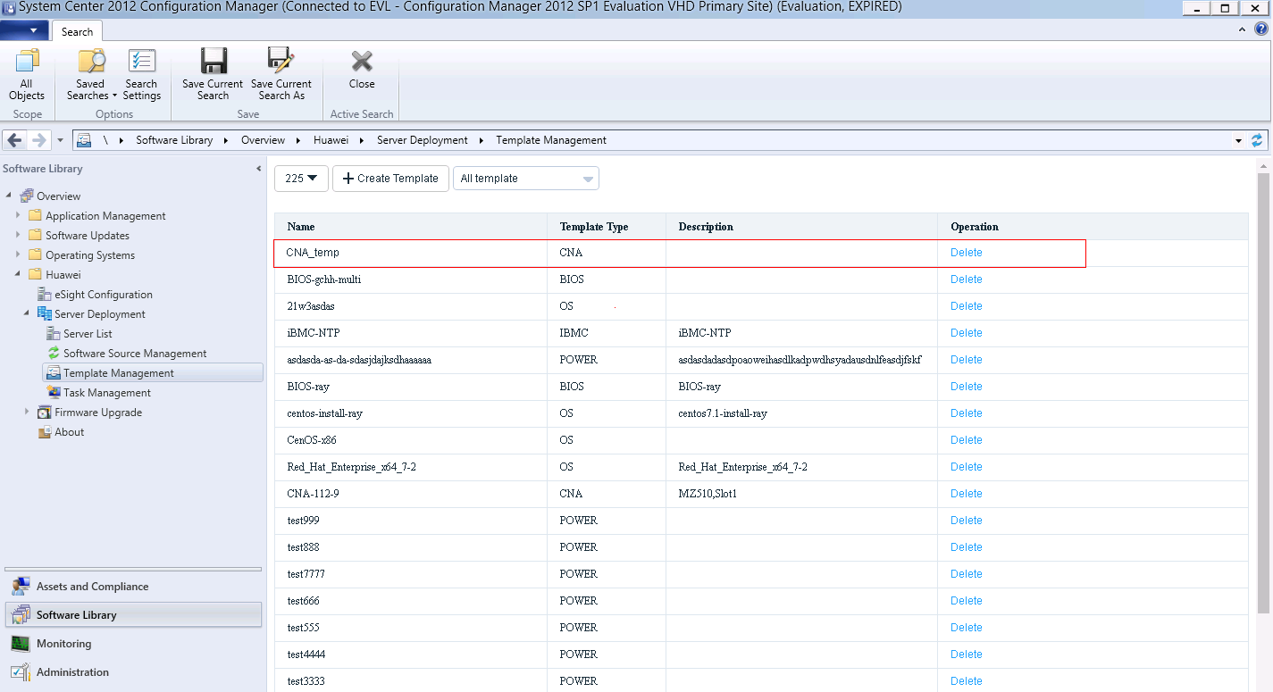

To delete a template, click **Delete** in the row where the template is located.

Add a CNA template task according to 3.2.2.3 Adding a Template Task.

----End

#### Configuring the iBMC

Log in to the SCCM server.

Choose **Start** > **Configuration Manager Console** to log in to the SCCM.



If **Configuration Manager Console** cannot be found on the **Start** panel, return to the desktop, right-click **Start**, choose **Search** from the shortcut menu, and enter **Configuration Manager Console** in the search box to find **Configuration Manager Console**.

The SCCM main window is displayed, as shown in Figure 3-82.

SCCM main window



Click **Software Library**.

The **Software Library** window is displayed, as shown in Figure 3-83.

Software Library



Choose **Huawei** > **Server Deployment** > **Template Management**.

The **Template Management** window is displayed, as shown in Figure 3-84.

Template Management



* **225** indicates the customized eSight name. You can select another eSight system from the drop-down list box.
* **All template** indicates that all templates are to be viewed. You can select another option from the drop-down list box to view specified templates. For example, you can select **OS template** to view OS templates.

Click **Create Template**.

The window for creating a template is displayed, as shown in Figure 3-85.

Creating a template



Set **Template Type** to **iBMC template**.

The window for creating an iBMC template is displayed, as shown in Figure 3-86.

Creating an iBMC template

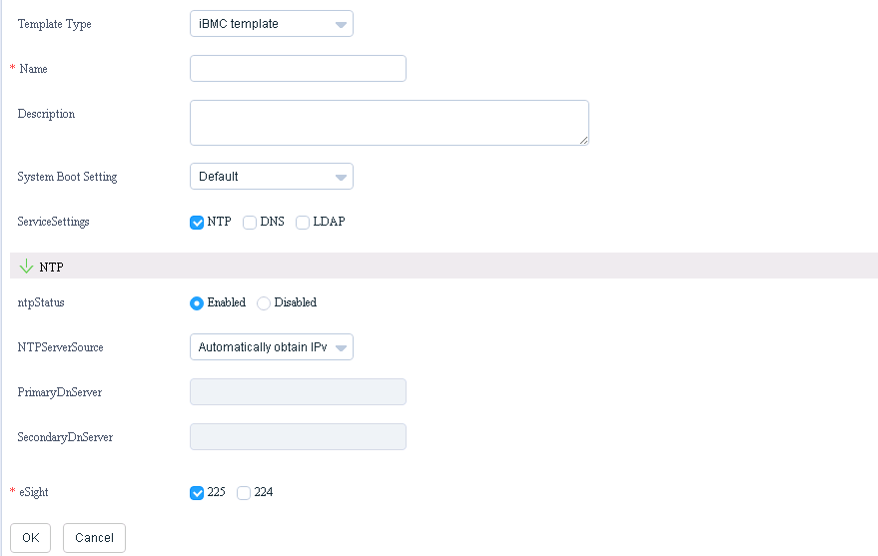

Enter iBMC template information according to Table 3-21, as shown in Figure 3-87.

Entering iBMC template information

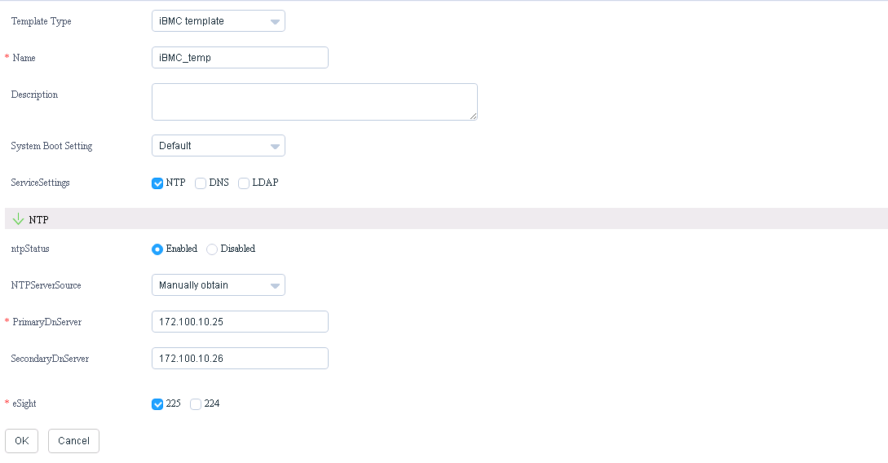

Parameter description

| Parameter | Description | Value | Mandatory |
| --- | --- | --- | --- |
| Name | Template name. | The value contains letters, digits, underscores, and hyphens (**-**). The length ranges from 6 to 32 characters. | Yes |
| Description | Template description. | The value contains 0 to 128 characters. | No |
| System Boot Setting | System boot option. | The options are as follows:   * Default * PXE * CD/DVD/ROM * Hard Disk * FDD | Yes |
| ServiceSettings | Configuration type. | The default value is **NTP**. You can select one or multiple of the following:   * NTP * DNS * LDAP | Yes |
| eSight | eSight. | You can select one or multiple eSight systems. | Yes |
| The NTP configuration information is as follows. | | | |
| ntpStatus | NTP status. | The default value is **Enabled**. The options are as follows:   * **Enabled**: enables this function. * **Disabled**: disables this function. | Yes |
| NTPServerSource | NTP service source. | The default value is **Automatically obtain IPv4**. The options are as follows:   * Automatically obtain IPv4 * Automatically obtain IPv6 * Manually obtain | Yes |
| PrimaryDnServer | Preferred NTP server. | * IPv4 address * IPv6 address * Domain name   NOTE  This parameter is involved only when **PFType** is set to **Manually obtain**. | Yes |
| SecondaryDnServer | Alternate NTP server. | * IPv4 address * IPv6 address * Domain name   NOTE  This parameter is involved only when **PFType** is set to **Manually obtain**. | No |
| The DNS configuration information is as follows. | | | |
| dnsSource | DNS obtaining mode. | The default value is **Automatically Obtain**. The options are as follows:   * Automatically Obtain * Manually Set | Yes |
| domainName | Domain name. | - | Yes |
| primaryDnsServer | Preferred DNS server. | Value range:   * IPv4 address * IPv6 address * Domain name   NOTE  This parameter is involved only when **dnsSource** is set to **Manually Set**. | Yes |
| secondaryDnsServer | Alternate DNS server. | * IPv4 address * IPv6 address * Domain name   NOTE  This parameter is involved only when **dnsSource** is set to **Manually Set**. | No |
| The LDAP configuration information is as follows. | | | |
| ldapStatus | LDAP status. | The default value is **Enabled**. The options are as follows:   * **Enabled**: enables this function. * **Disabled**: disables this function. | Yes |
| domainControllerAddress | Domain controller address. | - | Yes |
| userDomain | User domain. | The value contains 1 to 255 characters and cannot contain '#&," and spaces. The value is in **CN=XXX,DC=XXX** format. | Yes |
| roleGroup | Role group. | At least one role group is required. A maximum of five role groups can be created. | Yes |
| groupName | Group name. | - | Yes |
| groupDomain | Group domain. | - | Yes |
| groupPrivilege | Group privilege. | The default value is **Administrator**. The options are as follows:   * Operator * CommonUser * Administrator | Yes |

Click **OK**.

A dialog box indicating successful adding is displayed, as shown in Figure 3-88.

Dialog box



Click **OK**.

The iBMC template is added successfully, and you can view the added iBMC template in the template list, as shown in Figure 3-89.

Template list

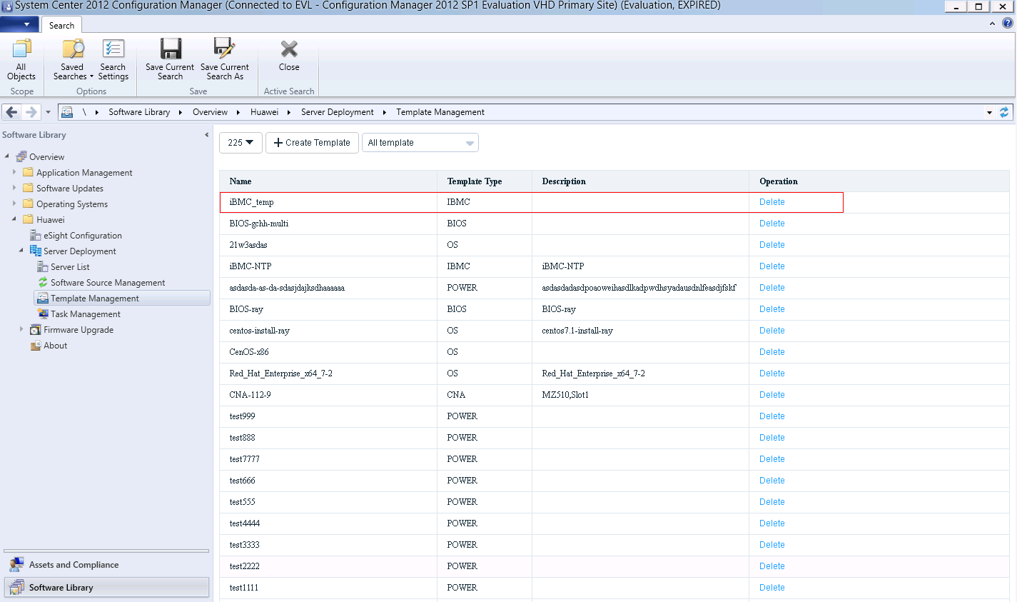

To delete a template, click **Delete** in the row where the template is located.

Add an iBMC template task according to 3.2.2.3 Adding a Template Task.

----End

### Upgrading the Firmware and Driver

#### Uploading an Upgrade Package

Prerequisites

The SFTP server for uploading the upgrade package has been set up.

Procedure

Log in to the SCCM server.

Choose **Start** > **Configuration Manager Console** to log in to the SCCM.



If **Configuration Manager Console** cannot be found on the **Start** panel, return to the desktop, right-click **Start**, choose **Search** from the shortcut menu, and enter **Configuration Manager Console** in the search box to find **Configuration Manager Console**.

The SCCM main window is displayed, as shown in Figure 3-90.

SCCM main window



Click **Software Library**.

The **Software Library** window is displayed, as shown in Figure 3-91.

Software Library



Choose **Huawei** > **Firmware Upgrade** > **File Management**.

The **File Management** window is displayed, as shown in Figure 3-92.

File Management

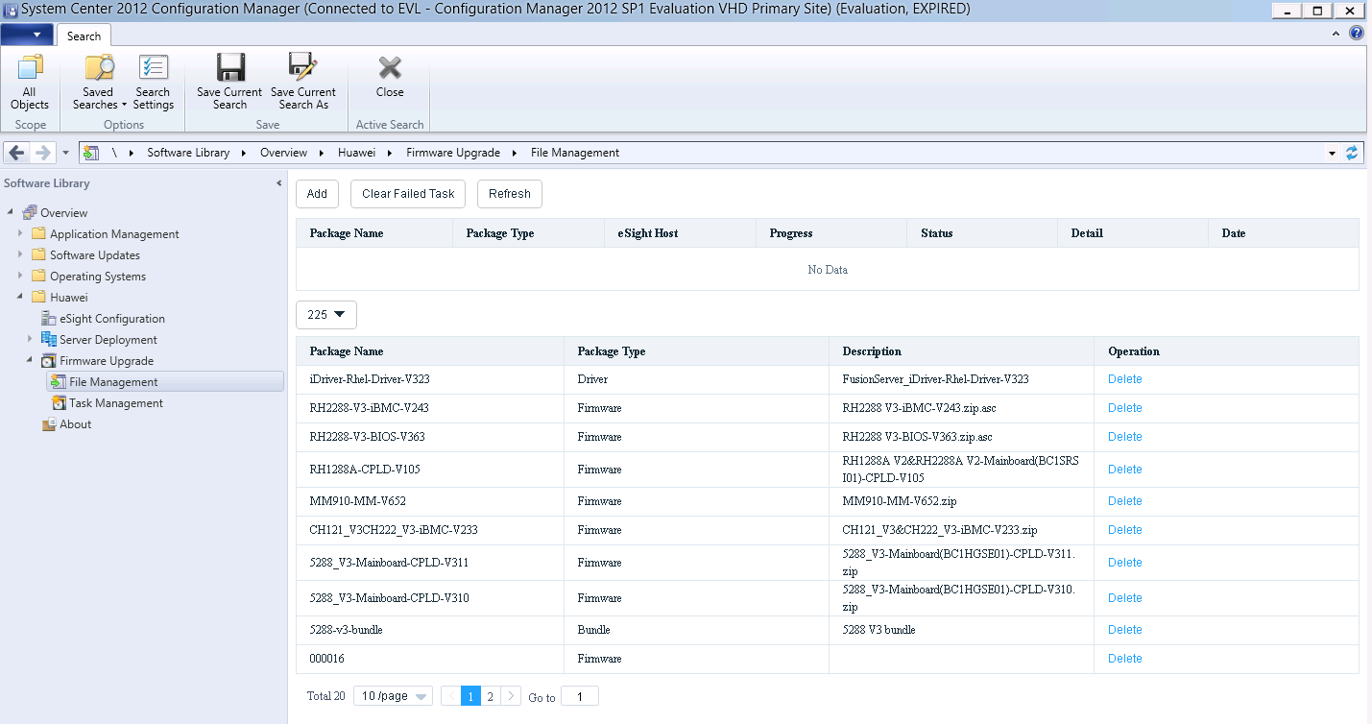

**225** indicates the customized eSight name. You can select another eSight system from the drop-down list box.

Upload an upgrade package.

1. Click **Add**.

The window for uploading an upgrade package is displayed, as shown in Figure 3-93.

Uploading an upgrade package

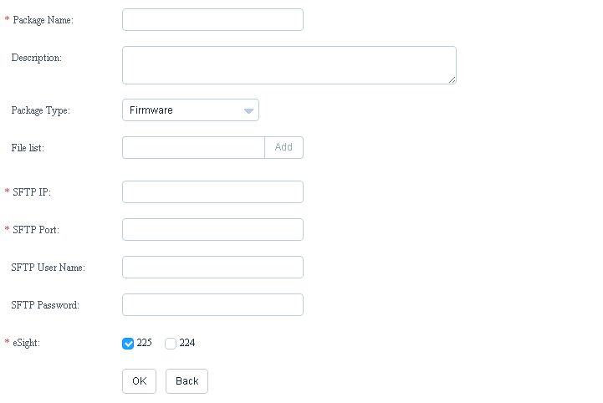

1. Enter upgrade package information according to Table 3-22, as shown in Figure 3-94.

Entering upgrade package information

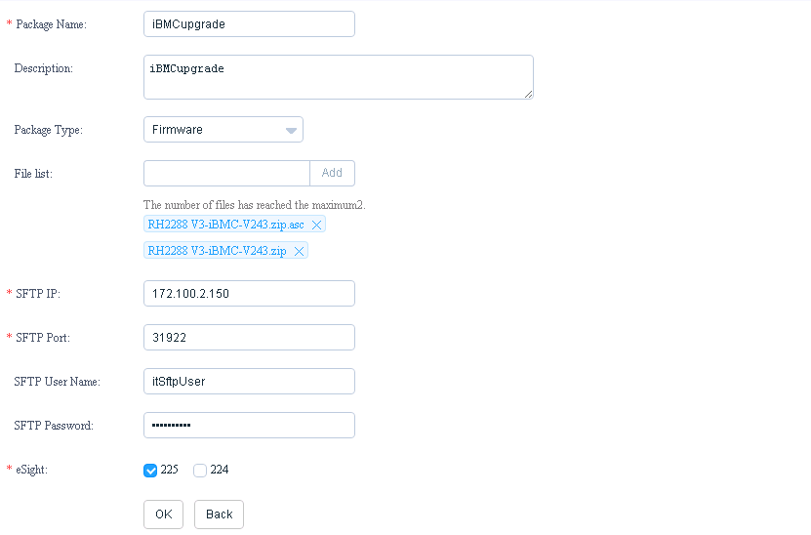

Parameter description

| Parameter | Description | Value | Mandatory |
| --- | --- | --- | --- |
| Name | Upgrade package name. | The value contains letters, digits, underscores, and hyphens (**-**). The length ranges from 6 to 32 characters. | Mandatory |
| Description | Upgrade package description. | The value contains 0 to 128 characters. | Optional |
| Package Type | Upgrade package type. | * Firmware * Driver * Bundle | Mandatory |
| File list | File list. | Enter the name (with **.zip**) of the upgrade package in the default path on the SFTP server, and click **Add**. A maximum of two files can be uploaded each time.  NOTE   * The upgrade package needs to be placed in the default path on the SFTP server in advance. * You need to upload the ZIP package and digital signature certificate if **Package Type** is set to **Firmware** or **Driver**. You need to upload only the ZIP package if **Package Type** is set to **Bundle**. | Mandatory |
| SFTP IP | SFTP server IP address. | - | Mandatory |
| SFTP Port | SFTP server port number. | 0 to 65535 | Mandatory |
| SFTP User Name | SFTP server user name. | The value contains 0 to 64 characters. | Mandatory |
| SFTP Password | SFTP server password. | The value contains 0 to 64 characters. | Mandatory |
| eSight | eSight. | You can select one or multiple eSight systems. | Mandatory |

1. Click **OK**.

A dialog box indicating successful adding is displayed, as shown in Figure 3-95.

Dialog box



1. Click **OK**.

The **File Management** window is displayed, as shown in Figure 3-96.

File Management

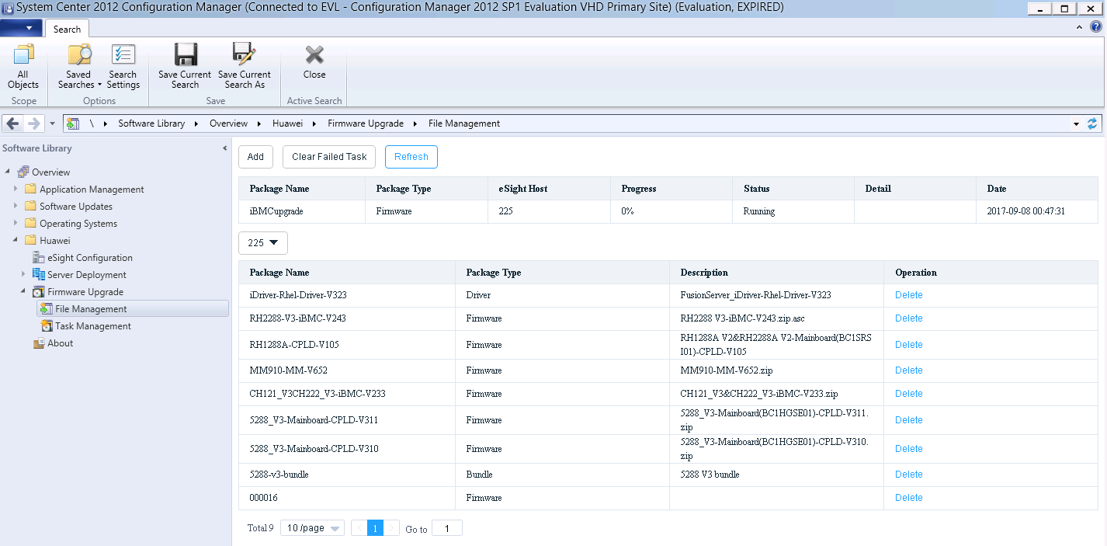

You can view the upgrade package uploading progress and status in the window. **Progress** indicates the uploading progress. **Status** indicates the uploading status. You can click **Refresh** to refresh the window.

When the value of **Progress** changes to **100%** and the value of **Status** changes to **Complete**, the upgrade package is uploaded successfully, as shown in Figure 3-97.

Upgrade package uploaded successfully

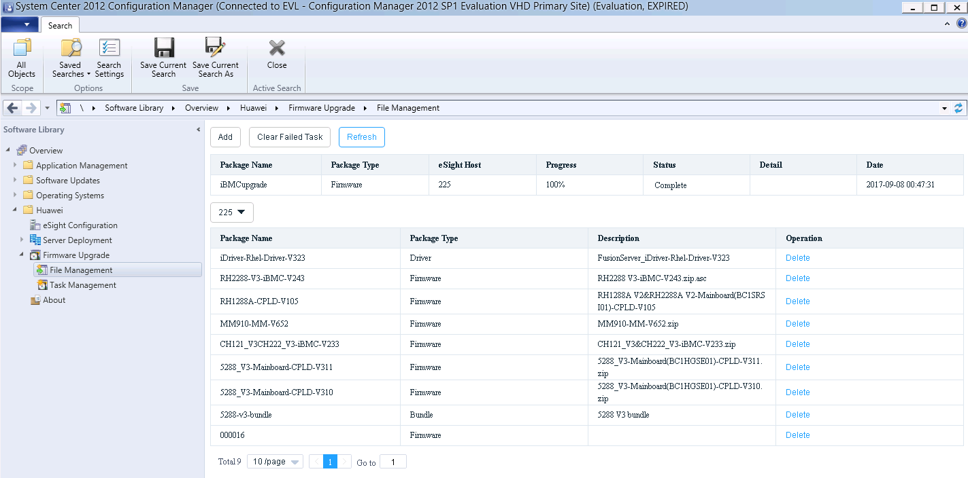

* If an upgrade package fails to be uploaded, the value of **Status** is **Failed**. You can click **Clear Failed Task** to delete all failed uploading tasks.
* You can click **Delete** in the row where an upgrade package is located in the upgrade package list to delete the upgrade package.
* You can click any position in the row where an upgrade package is located in the upgrade package list to view detailed information about the upgrade package.

----End

#### Upgrading the Firmware and Driver

Prerequisites

You have installed iBMA 2.0.0 or later on the OS of the managed server. You can log in to the [Support-E](http://support.huawei.com/enterprise/zh/index.html#) website and choose **Support > Servers > Server Management Software > iBMA** to obtain the software.

Procedure

Log in to the SCCM server.

Choose **Start** > **Configuration Manager Console** to log in to the SCCM.



If **Configuration Manager Console** cannot be found on the **Start** panel, return to the desktop, right-click **Start**, choose **Search** from the shortcut menu, and enter **Configuration Manager Console** in the search box to find **Configuration Manager Console**.

The SCCM main window is displayed, as shown in Figure 3-98.

SCCM main window



Click **Software Library**.

The **Software Library** window is displayed, as shown in Figure 3-99.

Software Library



Choose **Huawei** > **Firmware Upgrade** > **Task Management**.

The **Task Management** window is displayed, as shown in Figure 3-100.

Task Management

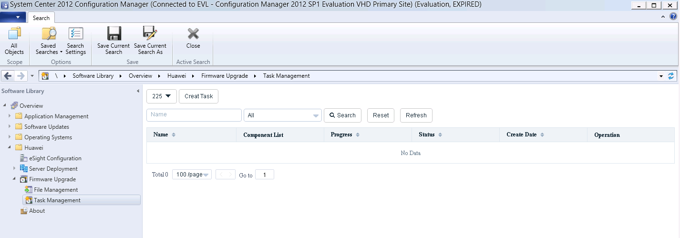

* **225** indicates the customized eSight name. You can select another eSight system from the drop-down list box.
* **All** indicates that all upgrade tasks are to be viewed. You can select another option from the drop-down list box to view specified upgrade tasks. For example, you can select **Complete** to view upgrade tasks that have been executed successfully.

Click **Creat Task**.

The window for creating an upgrade template task is displayed, as shown in Figure 3-101 and Figure 3-102.

Creating an upgrade task

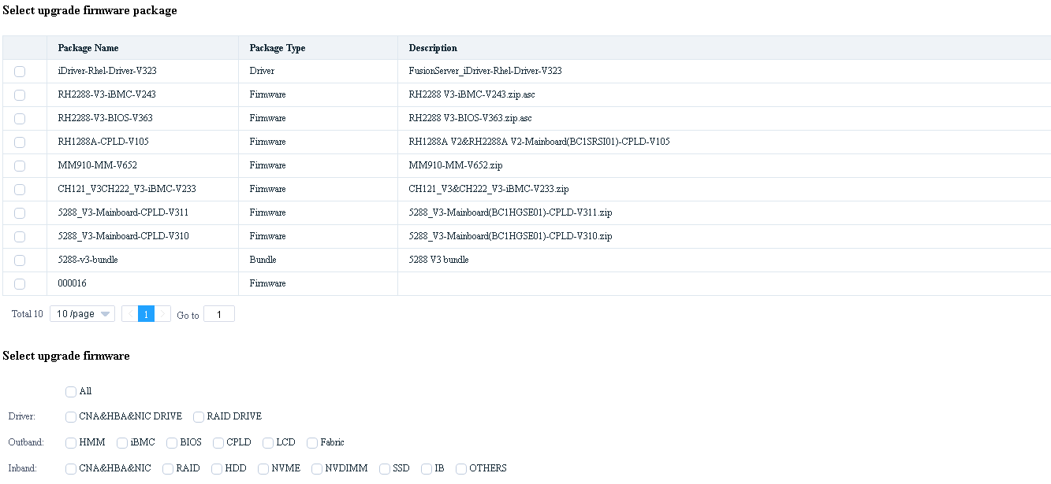

Creating an upgrade task

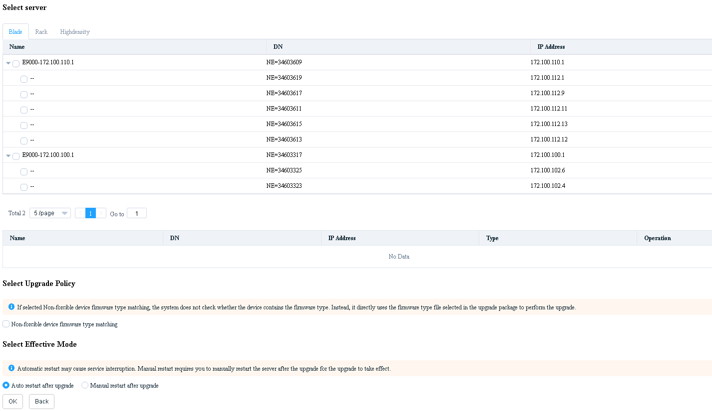

Enter upgrade information according to Table 3-23, and click **OK**.

A dialog box indicating successful creation is displayed, as shown in Figure 3-103.

Dialog box



Parameter description

| Parameter | Description | Mandatory |
| --- | --- | --- |
| Select upgrade firmware package | Upgrade package. | Mandatory |
| Select upgrade firmware | Firmware or driver to be upgraded. The value must match the selected upgrade package. | Mandatory |
| Select server | Server for which a firmware upgrade is to be performed. The value must be consistent with the server supported by the selected upgrade package. | Mandatory |
| Select Upgrade Policy | Forcible matching of the device firmware type. If **Non-forcible device firmware type matching** is selected, no device firmware type will be forcibly matched. | Mandatory |
| Select Effective Mode | Effective mode for the upgrade.   * **Auto restart after upgrade**: The upgrade takes effect after the server automatically restarts. * **Manual restart after upgrade**: The upgrade takes effect after the server is restarted manually. | Mandatory |

Click **OK**.

The **Task Management** window is displayed, as shown in Figure 3-104.

Task Management

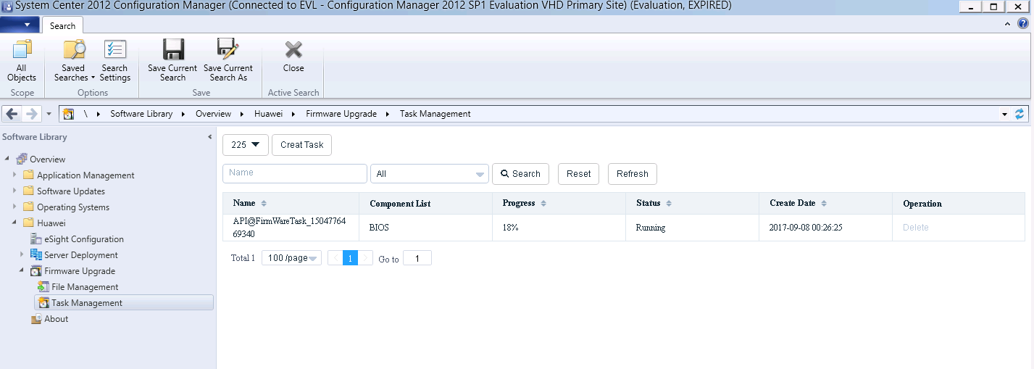

* You can view the upgrade progress and status in the window. **Progress** indicates the upgrade progress. **Status** indicates the upgrade status. You can click **Refresh** to refresh the window.
* If you want to delete an upgrade task when the value of **Progress** changes to **100%**, you can click **Delete** in the row where the upgrade task is located.

When the value of **Progress** changes to **100%**, click any position in the row where the task is located.

Detailed task information is displayed, as shown in Figure 3-105.

Detailed task information

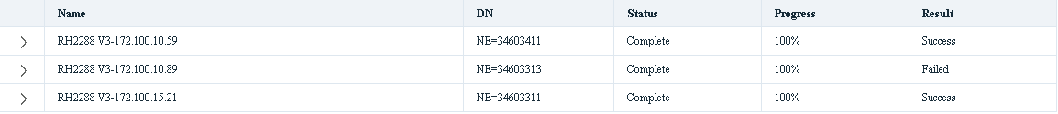

If the value of **Result** is **Success**, the template task is executed successfully on the server. If the value of **Result** is **Failed**, the template task fails on the server.

----End

## Viewing the Huawei SCCM Plug-in Version

Log in to the SCCM server.

Choose **Start** > **Configuration Manager Console** to log in to the SCCM.



If **Configuration Manager Console** cannot be found on the **Start** panel, return to the desktop, right-click **Start**, choose **Search** from the shortcut menu, and enter **Configuration Manager Console** in the search box to find **Configuration Manager Console**.

The SCCM main window is displayed, as shown in Figure 3-106.

SCCM main window



Click **Software Library**.

The **Software Library** window is displayed, as shown in Figure 3-107.

Software Library



Choose **Huawei** > **About**.

The **About** window is displayed, as shown in Figure 3-108.

About

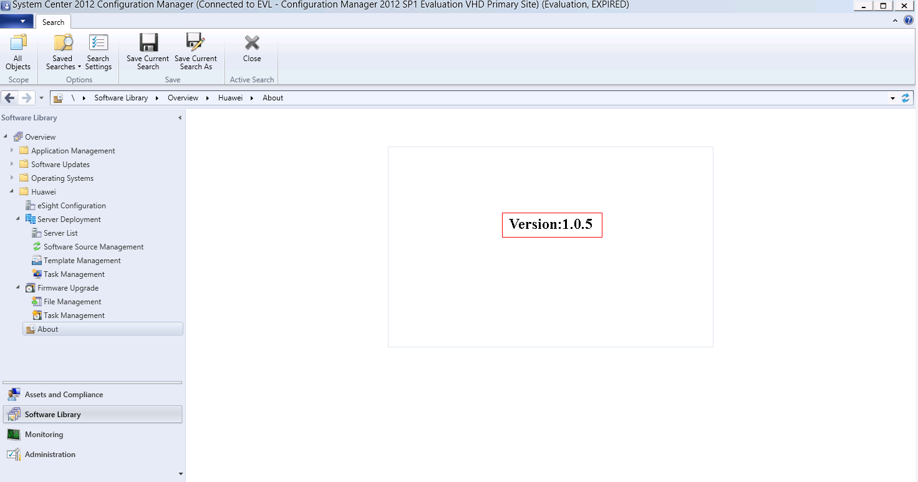

The value of **Version** is the Huawei SCCM plug-in version.

----End

# FAQs

4.1 Connection Test Failed When Adding an eSight

4.2 Failed to Deploy an OS

4.3 Failed to Upload an Upgrade Package

## Connection Test Failed When Adding an eSight

Symptom

After an eSight server is added, a failure message is displayed during the connection test.

Cause

* The user name or password is incorrect.
* The eSight northbound interface user is locked.
* A whitelist has not been set.

Solution

* The user name or password is incorrect.

Enter the user name and password of the eSight northbound interface user. To view the user name and password, perform the following steps:

* 1. Log in to the eSight WebUI.
  2. Choose **System** > **User Management** > **User**. The **User** page is displayed.

The role of the eSight northbound interface user is **Open API user group**, and the user name is displayed under **User Name**.

Viewing information about the eSight northbound interface user



* 1. Click to display the dialog box for resetting the user password.



Reset Password

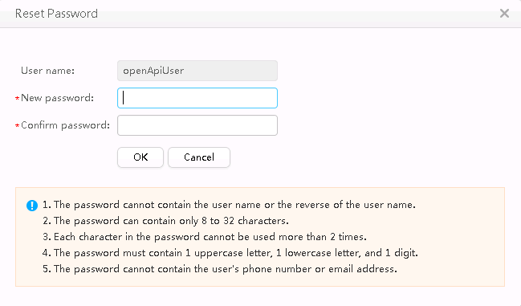

* 1. Enter a password in **New password** and **Confirm password**.
  2. Click **OK**. The password is reset.
* The eSight northbound interface user is locked.

To unlock a user, perform the following steps:

* 1. Log in to the eSight WebUI.
  2. Choose **System** > **User Management** > **User**.

The **User** page is displayed.

* 1. Click to set **Status** of the eSight northbound interface user to **Enabled**.



Unlocking a user



* A whitelist has not been set.
  1. Log in to the eSight WebUI.
  2. Choose **System** > **Northbound Integration** > **Third-party System** > **Create**.

The **Third-party System** page is displayed, as shown in Figure 4-4.

Third-party System



* 1. Set the following parameters:
  2. **IP address**: Set this parameter to the IP address of the SCCM server.
  3. **Protocol type**: Select **HTTPS**.
  4. **System ID**: Retain the default value or enter a new value. The value can be an IP address or a string of 1 to 64 characters, including digits (0-9), lowercase letters (a-z), uppercase letters (A-Z), and special characters @_- (), .^$~`!.
  5. Click **OK**.

The IP address of the SCCM server is set as a whitelist, as shown in Figure 4-5.

Set successfully



## Failed to Deploy an OS

Symptom and Cause Analysis

| Symptom | Cause Analysis |
| --- | --- |
| The message "Failed to mount ServiceCD" is displayed. | * The server is mounted and occupied by other virtual media. * SNMP V3 protocol parameters of a server are incorrectly configured when the server is added to eSight. |
| The system displays a message indicating that the ServiceCD does not exist or the file name is incorrect. | The eSight installation path does not contain the ServiceCD software or the ServiceCD file name is incorrect. |
| Others | * No RAID is created in the RAID controller card. * The server or RAID controller card does not support the deployed OS. |

Solution

* The server is mounted and occupied by other virtual media.

Unmount the virtual media by performing the following steps:

* 1. Log in to iBMC WebUI.
  2. Choose **Remote Console** > **Virtual Media**.

The **Virtual Media** page is displayed.

Virtual Media

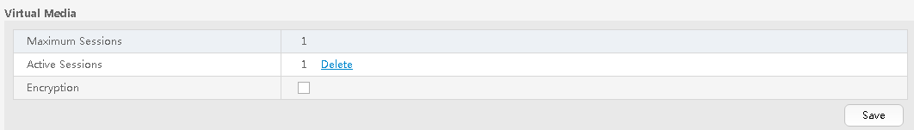

* 1. If the value of **Active Sessions** is **1**, the virtual media has been mounted.

Click **Delete**. The **Confirm** dialog box is displayed.

Confirm

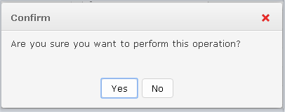

* 1. Select **Yes** to unmount the virtual media.
  2. Perform the deployment task again. For details, see 3.2.2 Deploying an OS.
* SNMP V3 protocol parameters of a server are incorrectly configured when the server is added to eSight.

Check whether SNMP V3 parameters are correct.

* 1. Log in to the eSight WebUI.
  2. Choose **Resource** > **Server** > **Server Device** > **Rack Server**.

The rack server page is displayed.

Rack server page

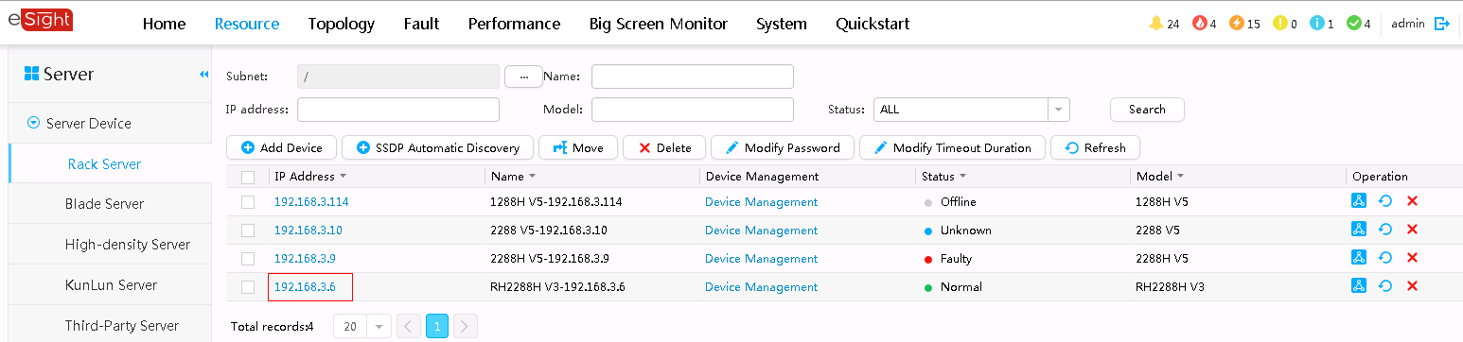

* 1. Select a server. The detailed server information is displayed.
  2. Choose **Settings** > **Protocol Parameters**.

Viewing detailed server information

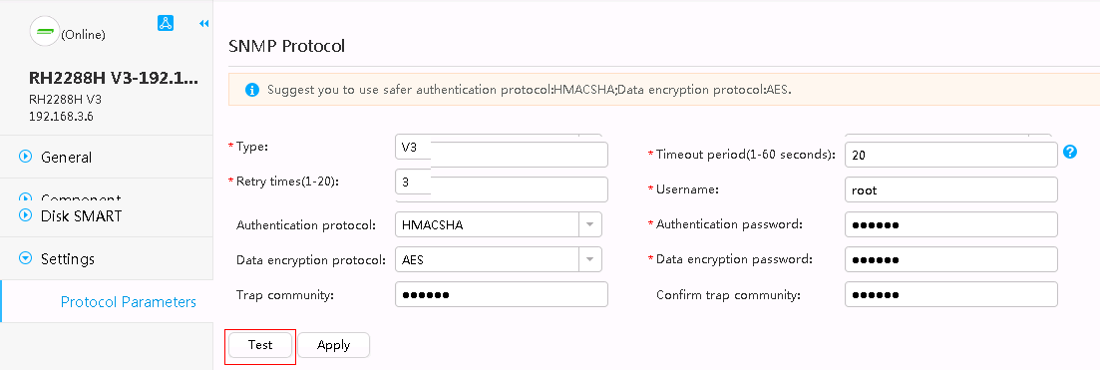

* 1. Click **Test** to test the SNMP protocol.
  2. If the **Succeeded** dialog box is displayed, the SNMP protocol is correct.
  3. If the **Error** dialog box is displayed, the SNMP protocol is incorrect. Enter correct SNMP V3 parameters.

SNMP Protocol

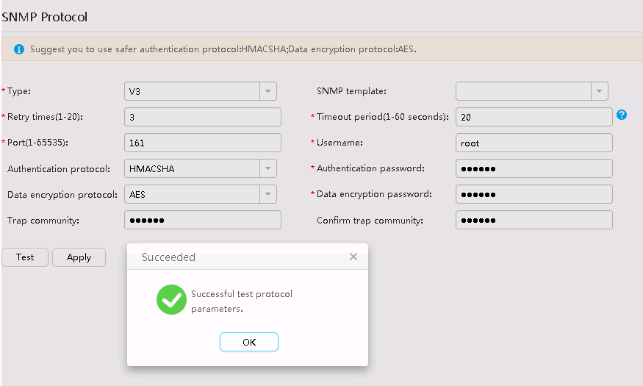

* The eSight installation path does not contain the ServiceCD software or the ServiceCD file name is incorrect.
  1. Download the ServiceCD from the **Software Download** tab on the [**FusionServer Tools**](https://support.huawei.com/enterprise/en/servers/fusionserver-tools-pid-21015513/software) page at [Huawei Enterprise](http://support.huawei.com/enterprise/en/index.html) support website.
  2. Decompress the downloaded software package.

Decompressed ServiceCD software package

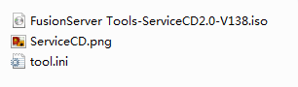

* 1. Change the name of the **.iso** file to **FusionServer Tools-ServiceCD2.0-V110.iso**.
  2. Copy **FusionServer Tools-ServiceCD2.0-V110.iso** to eSight installation directory**\AppBase\var\iemp\data\ftp\**.
* No RAID is created in the RAID controller card.

For details about how to create a RAID, see 3.2.3.4 Configuring RAID.

* The server or RAID controller card does not support the deployed OS.

You can check the compatibility between the server, OS, and RAID controller card by using the [Huawei Server Compatibility Checker](http://support.huawei.com/onlinetoolsweb/ftca/indexEn?serise=2).

Ensure that Note1 is present in the **Notes** column.

Checking the OS compatibility

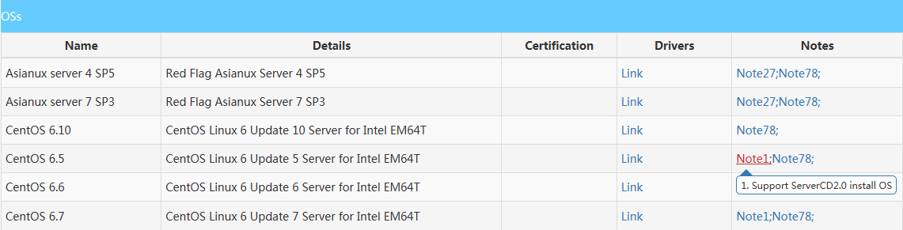

## Failed to Upload an Upgrade Package

Symptom

The message "The description of the firmware type does not match the actual firmware type" is displayed.



Cause

The downloaded driver package is not applicable.

Solution

1. Log in to [Huawei Enterprise](http://support.huawei.com/enterprise/en/index.html) support website.
2. In the **PRODUCT SUPPORT** area, choose **Enterprise Data Center** > **Servers** > **Server Management Software** > **FusionServer iDriver**.
3. Click the **FusionServer iDriver** tab.
4. Click the desired driver version.
5. Download the correct driver package. Ensure that the driver package contains the **driver.xml** file.
6. Obtaining Help
   1. Preparing to Contact Huawei Technical Support

If a fault persists during routine maintenance or troubleshooting, contact Huawei technical support.

To rectify a fault, make the following preparations before you contact Huawei technical support.

Collecting Fault Information

You need to collect the following information:

* Your company name and detailed address
* Name and telephone number of the contact person
* Time when the fault occurred
* Fault symptom
* Device type and software version
* Measures taken after the fault occurred and results
* Fault severity and deadline for rectifying the fault

Preparing for Debugging

When you seek technical support, Huawei technical support may ask you to perform some operations to further collect fault information or even rectify the fault. You need to make preparations before seeking technical support. For example, prepare spare server parts and controller cards, screwdrivers, screws, serial cables, network cables, and other necessary objects.

* 1. Obtaining Help from Huawei Support Website

Huawei provides timely and efficient technical support over local offices, secondary technical support systems, telephones, remote technologies, and onsite instructions.

Huawei technical support system consists of:

* Technical Support Department at Huawei Headquarters
* Technical support centers in local offices
* Huawei support website
* Customer service center

Huawei support website: <http://support.huawei.com/enterprise>

To view the latest product documentation at http://support.huawei.com, perform the following steps:

1. Log in to <http://support.huawei.com/enterprise>.
2. Click **Login**. The **Login** page is displayed.
3. Enter your user name, password, and verification code, and click **Login**. The **Technical Support** page is displayed.
4. In the navigation tree, click **TECHNICAL SUPPORT > Technical Support > Product and Solution Support** and select a product manual based on the product name.



Alternatively, you can quickly locate a product manual by entering a keyword in the **Search** text box in the upper right corner of the web page.